Activated Sludge Design Equations
(Complete Mix Reactor)
Schematic of activated sludge unit
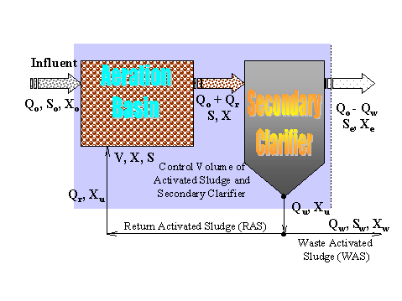
Mass balance of biomass production
- Influent biomass + biomass production = effluent biomass + sludge wasted
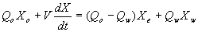
- Substitute biomass production equation
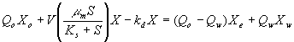
- Assume that influent and effluent biomass concentrations are negligible and solve
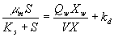
Mass balance of food substrate
- Influent substrate + substrate consumed = effluent susbtrate + sludge wasted substrate
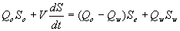
- Substitute substrate removal equation
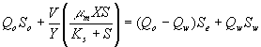
- Assume that no biochemical action takes place in clarifier. Therefore the substrate concentration in the aeration basin is equal to the substrate concentrations in the effluent and the waste activated sludge. Solve:
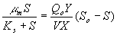
Overall equations
  - Combine the mass balance equations for food and biomass:
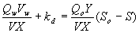
- The cell residence time is:
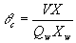
and the hydraulic retention time is,θ = V/Q_{o}
- Substitute and rearrange:
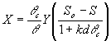
- Compute the F/M ratio
