Introduction
Dissolved oxygen (DO) is probably the single most important environmental factor in aquaculture. If DO concentrations are low fish will not eat well, they will not grow well, and they will be susceptible to disease. Furthermore, where concentrations are very low, many or even all of the fish may die from lack of oxygen. In order to have good feed conversion efficiency, high survival, and adequate profits, fish farmers must maintain plenty of DO in waters of culture systems. Aeration is necessary to supplement natural sources of DO.
Although aeration is widely used, there are many mistaken ideas about aeration and few aeration practices have been thoroughly investigated. In this lecture, I will provide some basic information on DO and on the practice of aeration. Improvements in management procedures such as aeration are very important for fish prices will probably continue to be low. This will increase the demand for fish, but it will force farmers to become more efficient managers. Just to illustrate how a small factor can be important to profit, consider that an improvement in the feed conversion efficiency of 0.1 unit could potentially increase profits by $25 to $40 per ton of fish produced.

Solubility of Oxygen in Water
Approximately 20 % of the volume and pressure of gases in the air is oxygen.

Table 1-1. The solubility of oxygen (mg/L) in water at different temperatures and salinities from moist air with pressure of 760 mm Hg.
Salinity (mg/L)
T (°C) | 0 | 5,000 | 10,000 | 15,000 | 20,000
0 | 14.62 | 13.79 | 12.97 | 12.14 | 11.32
1 | 14.23 | 13.41 | 12.61 | 11.82 | 11.03
2 | 13.84 | 13.05 | 12.28 | 11.52 | 10.76
3 | 13.48 | 12.72 | 11.98 | 11.24 | 10.50
4 | 13.13 | 12.41 | 11.69 | 10.97 | 10.25
5 | 12.80 | 12.09 | 11.39 | 10.70 | 10.01
6 | 12.48 | 11.79 | 11.12 | 10.45 | 9.78
7 | 12.17 | 11.51 | 10.85 | 10.21 | 9.57
8 | 11.87 | 11.24 | 10.61 | 9.98 | 9.36
9 | 11.59 | 10.97 | 10.36 | 9.76 | 9.17
10 | 11.33 | 10.73 | 10.13 | 9.55 | 8.98
11 | 11.08 | 10.49 | 9.92 | 9.35 | 8.80
12 | 10.83 | 10.28 | 9.72 | 9.17 | 8.62
13 | 10.60 | 10.05 | 9.52 | 8.98 | 8.46
14 | 10.37 | 9.85 | 9.32 | 8.80 | 8.30
15 | 10.15 | 9.65 | 9.14 | 8.63 | 8.14
16 | 9.95 | 9.46 | 8.96 | 8.47 | 7.89
17 | 9.74 | 9.26 | 8.78 | 8.30 | 7.84
18 | 9.54 | 9.07 | 8.62 | 8.15 | 7.70
19 | 9.35 | 8.89 | 8.45 | 8.00 | 7.56
20 | 9.17 | 8.73 | 8.30 | 7.86 | 7.42
21 | 8.99 | 8.57 | 8.14 | 7.71 | 7.28
22 | 8.83 | 8.42 | 7.99 | 7.57 | 7.14
23 | 8.68 | 8.27 | 7.85 | 7.43 | 7.00
24 | 8.53 | 8.12 | 7.71 | 7.30 | 6.87
25 | 8.38 | 7.96 | 7.56 | 7.15 | 6.74
26 | 8.22 | 7.81 | 7.42 | 7.02 | 6.61
27 | 8.07 | 7.67 | 7.28 | 6.88 | 6.49
28 | 7.77 | 7.39 | 7.00 | 6.62 | 6.25
29 | 7.70 | 7.32 | 6.93 | 6.56 | 6.19
30 | 7.63 | 7.25 | 6.86 | 6.49 | 6.13

When water is in contact with the atmosphere, oxygen from the air will enter the water until the pressure of oxygen in water and air are equal. This condition is known as equilibrium or saturation. The concentration of DO at equilibrium increases with increasing pressure and decreases with increasing water temperature and salinity. The equilibrium (saturation) concentrations of DO at different temperatures and salinities are provided in Table 1 for standard sea level barometric pressure (760 mm Hg or 29.92 inches of Hg). To obtain the DO concentration at saturation for any other location, multiply the appropriate DO value from Table 1 by the ratio local barometric pressure : standard sea level pressure.
Table 1-2. The solubility of oxygen in water in equilibrium with air at 760 mm Hg pressure and 100 % relative humidity (Units : mg/L).
T (°C) | 0.0 | 0.1 | 0.2 | 0.3 | 0.4 | 0.5 | 0.6 | 0.7 | 0.8 | 0.9
0 | 14.60 | 14.65 | 14.52 | 14.48 | 14.44 | 14.40 | 14.36 | 14.33 | 14.29 | 14.25
1 | 14.21 | 14.17 | 14.13 | 14.09 | 14.05 | 14.02 | 13.98 | 13.94 | 13.90 | 13.87
2 | 13.83 | 13.79 | 13.75 | 13.72 | 13.68 | 13.64 | 13.61 | 13.57 | 13.54 | 13.50
3 | 13.46 | 13.43 | 13.39 | 13.36 | 13.32 | 13.29 | 13.25 | 13.22 | 13.18 | 13.15
4 | 13.11 | 13.08 | 13.04 | 13.01 | 12.98 | 12.94 | 12.91 | 12.88 | 12.84 | 12.81
5 | 12.78 | 12.74 | 12.71 | 12.68 | 12.64 | 12.61 | 12.58 | 12.55 | 12.52 | 12.48
6 | 12.45 | 12.45 | 12.39 | 12.36 | 12.33 | 12.29 | 12.26 | 12.23 | 12.20 | 12.17
7 | 12.14 | 12.11 | 12.08 | 12.05 | 12.02 | 11.99 | 11.96 | 11.93 | 11.90 | 11.87
8 | 11.84 | 11.81 | 11.78 | 11.76 | 11.73 | 11.70 | 11.67 | 11.64 | 11.61 | 11.58
9 | 11.56 | 11.53 | 11.50 | 11.47 | 11.44 | 11.42 | 11.39 | 11.36 | 11.34 | 11.31
10 | 11.28 | 11.25 | 11.23 | 11.20 | 11.17 | 11.15 | 11.12 | 11.10 | 11.07 | 11.04
11 | 11.02 | 10.99 | 10.97 | 10.94 | 10.91 | 10.89 | 10.86 | 10.84 | 10.81 | 10.79
12 | 10.76 | 10.74 | 10.72 | 10.69 | 10.67 | 10.64 | 10.62 | 10.59 | 10.57 | 10.55
13 | 10.54 | 10.50 | 10.47 | 10.45 | 10.43 | 10.40 | 10.38 | 10.36 | 10.34 | 10.31
14 | 10.29 | 10.27 | 10.24 | 10.22 | 10.20 | 10.18 | 10.15 | 10.13 | 10.11 | 10.09
15 | 10.07 | 10.04 | 10.02 | 10.00 | 9.98 | 9.96 | 9.94 | 9.92 | 9.89 | 9.87
16 | 9.85 | 9.83 | 9.81 | 9.79 | 9.77 | 9.75 | 9.73 | 9.71 | 9.69 | 9.67
17 | 9.65 | 9.63 | 9.61 | 9.59 | 9.57 | 9.55 | 9.53 | 9.51 | 9.49 | 9.47
18 | 9.45 | 9.43 | 9.41 | 9.39 | 9.37 | 9.36 | 9.34 | 9.32 | 9.30 | 9.28
19 | 9.26 | 9.24 | 9.23 | 9.21 | 9.19 | 9.17 | 9.15 | 9.13 | 9.12 | 9.10
20 | 9.08 | 9.06 | 9.05 | 9.03 | 9.01 | 8.99 | 8.89 | 8.96 | 8.94 | 8.92
21 | 8.91 | 8.89 | 8.87 | 8.86 | 8.84 | 8.82 | 8.81 | 8.79 | 8.77 | 8.76
22 | 8.74 | 8.72 | 8.71 | 8.69 | 8.67 | 8.66 | 8.64 | 8.63 | 8.61 | 8.59
23 | 8.58 | 8.56 | 8.55 | 8.53 | 8.51 | 8.50 | 8.48 | 8.47 | 8.45 | 8.44
24 | 8.42 | 8.41 | 8.39 | 8.38 | 8.36 | 8.35 | 8.33 | 8.32 | 8.30 | 8.29
25 | 8.27 | 8.26 | 8.24 | 8.23 | 8.21 | 8.20 | 8.18 | 8.17 | 8.16 | 8.14
26 | 8.13 | 8.11 | 8.10 | 8.08 | 8.07 | 8.06 | 8.04 | 8.03 | 8.01 | 8.00
27 | 7.99 | 7.97 | 7.96 | 7.94 | 7.93 | 7.92 | 7.90 | 7.89 | 7.88 | 7.86
28 | 7.85 | 7.84 | 7.82 | 7.81 | 7.80 | 7.78 | 7.77 | 7.76 | 7.74 | 7.73
29 | 7.72 | 7.70 | 7.69 | 7.68 | 7.66 | 7.65 | 7.64 | 7.63 | 7.61 | 7.60
30 | 7.59 | 7.57 | 7.56 | 7.55 | 7.54 | 7.52 | 7.51 | 7.50 | 7.49 | 7.47

Sources of Oxygen

Natural Diffusion
When water contains less oxygen than the saturation concentration, oxygen from the atmosphere diffuses into the water. In culture tanks, diffusion is a slow process. It is not an important source of oxygen except when DO concentrations are low and there is a high degree of turbulence.

Inflowing Water

Water entering culture systems contains DO. The amount of O₂ from this source depends on the DO concentration and volume of inflowing water. For example, if water containing 9 mg/I DO enters a culture tank at 200 liters per minute, the O₂ input rate is 1,800 mg/min or 1.8 g/min. In 24 hr, 2,592 g or 2.59 kg of O₂ would enter the tank.

Table 1-3. Solubility of oxygen in mg/L as a function of temperature (mount air barometric pressure = 760 mm Hg, salinity = 0.0 ppt).
T (°C) | 0.0 | 0.1 | 0.2 | 0.3 | 0.4 | 0.5 | 0.6 | 0.7 | 0.8 | 0.9
0 | 14.602 | 14.561 | 14.520 | 14.479 | 14.438 | 14.398 | 14.358 | 14.318 | 14.278 | 14.238
1 | 14.198 | 14.159 | 14.120 | 14.081 | 14.042 | 14.004 | 13.969 | 13.927 | 13.889 | 13.851
2 | 13.813 | 13.776 | 13.738 | 13.701 | 13.664 | 13.627 | 13.591 | 13.554 | 13.518 | 13.482
3 | 13.445 | 13.410 | 13.374 | 13.338 | 13.303 | 13.268 | 13.233 | 13.198 | 13.163 | 13.128
4 | 13.094 | 13.060 | 13.025 | 12.991 | 12.957 | 12.924 | 12.890 | 12.857 | 12.823 | 12.790
5 | 12.757 | 12.725 | 12.692 | 12.659 | 12.627 | 12.595 | 12.563 | 12.531 | 12.499 | 12.467
6 | 12.436 | 12.404 | 12.373 | 12.342 | 12.311 | 12.280 | 12.249 | 12.218 | 12.188 | 12.158
7 | 12.127 | 12.097 | 12.067 | 12.037 | 12.008 | 11.978 | 11.949 | 11.919 | 11.980 | 11.861
8 | 11.832 | 11.803 | 11.774 | 11.746 | 11.717 | 11.689 | 11.661 | 11.632 | 11.604 | 11.577
9 | 11.549 | 11.521 | 11.493 | 11.466 | 11.439 | 11.412 | 11.384 | 11.357 | 11.331 | 11.304
10 | 11.277 | 11.251 | 11.224 | 11.198 | 11.172 | 11.145 | 11.119 | 11.093 | 11.068 | 11.042
11 | 11.016 | 10.991 | 10.995 | 10.940 | 10.915 | 10.890 | 10.865 | 10.864 | 10.815 | 10.791
12 | 10 766 | 10.741 | 10.717 | 10.693 | 10.669 | 10.645 | 10.620 | 10.597 | 10.573 | 10.549
13 | 10.525 | 10.502 | 10.478 | 10.455 | 10.432 | 10.409 | 10.386 | 10.363 | 10.340 | 10.317
14 | 10.294 | 10.271 | 10.249 | 10.226 | 10.204 | 10.182 | 10.160 | 10.137 | 10.115 | 10.094
15 | 10.072 | 10.050 | 10.028 | 10.007 | 9.985 | 9.964 | 9.942 | 9.921 | 9.900 | 9.879
16 | 9.858 | 9.837 | 9.816 | 9.795 | 9.774 | 9.753 | 9.733 | 9.712 | 9.692 | 9.672
17 | 9.651 | 9.631 | 9.611 | 9.591 | 9.571 | 9.551 | 9.531 | 9.512 | 9.492 | 9.472
18 | 9.453 | 9.433 | 9.414 | 9.395 | 9.375 | 9.356 | 9.337 | 9.318 | 9.299 | 9.280
19 | 9.261 | 9.242 | 9.224 | 9.205 | 9.187 | 9.168 | 9.150 | 9.131 | 9.113 | 9.095
20 | 9.077 | 9.058 | 9.040 | 9.022 | 9.004 | 8.987 | 8.969 | 8.951 | 8.933 | 8.916
21 | 8.989 | 8.881 | 8.863 | 8.846 | 8.829 | 8.812 | 8.794 | 8.777 | 8.760 | 8.743
22 | 8.726 | 8.709 | 8.693 | 8.676 | 8.659 | 8.642 | 8.626 | 8.609 | 8.583 | 8.576
23 | 8.560 | 8.544 | 8.528 | 8.511 | 8.495 | 8.479 | 8.463 | 8.447 | 8.431 | 8.415
24 | 8.400 | 8.384 | 8.368 | 8.352 | 8.337 | 8.321 | 8.306 | 8.290 | 8.275 | 8.260
25 | 8.244 | 8. 29 | 9.214 | 8.199 | 8.184 | 8.168 | 8.153 | 8.139 | 8.124 | 8.109
26 | 8.094 | 8.079 | 8.065 | 8.050 | 8.035 | 8.021 | 8.006 | 7.992 | 7.977 | 7.963
27 | 7.949 | 7.934 | 7.920 | 7.906 | 7.892 | 7.878 | 7.864 | 7.850 | 7.836 | 7.822
28 | 7.808 | 7.794 | 7.780 | 7.766 | 7.753 | 7.739 | 7.725 | 7.712 | 7.698 | 7.685
29 | 7.671 | 7.658 | 7.645 | 7.631 | 7.618 | 7.605 | 7.592 | 7.578 | 7.565 | 7.552
30 | 7.539 | 7.526 | 7.513 | 7.500 | 7.487 | 7.475 | 7.462 | 7.449 | 7.436 | 7.424
31 | 7.411 | 7.398 | 7.386 | 7.373 | 7.361 | 7.348 | 7.336 | 7.324 | 7.311 | 7.299
32 | 7.287 | 7.274 | 7.262 | 7.250 | 7.238 | 7.226 | 7.214 | 7.202 | 7.190 | 7.178
33 | 7.166 | 7.154 | 7.142 | 7.130 | 7.119 | 7.107 | 7.095 | 7.083 | 7.072 | 7.060
34 | 7.049 | 7.037 | 7.026 | 7.014 | 7.003 | 6.991 | 6.980 | 6.969 | 6.957 | 6.946
35 | 6.935 | 6.924 | 6.912 | 6.901 | 6.890 | 6.879 | 6.868 | 6.857 | 6.846 | 6.835
36 | 6.824 | 6.813 | 6.802 | 6.791 | 6.781 | 6.770 | 6.759 | 6.748 | 6.738 | 6.727
37 | 6.716 | 6.706 | 6.695 | 6.685 | 6.674 | 6.664 | 6.653 | 6.643 | 6.632 | 6.622
38 | 6.612 | 6.601 | 6.591 | 6.581 | 6.570 | 6.560 | 6.550 | 6.540 | 6.530 | 6.520
39 | 6.509 | 6.499 | 6.489 | 6.479 | 6.469 | 6.460 | 6.450 | 6.440 | 6.430 | 6.420
40 | 6.410 | 6.400 | 6.391 | 6.381 | 6.371 | 6.361 | 6.352 | 6.342 | 6.333 | 6.323

Aeration
When DO concentrations are below saturation, aerators can put oxygen into water. The amount of oxygen from aeration depends upon the type and number of aerators and upon the concentration of DO in the water. Aeration is an important source of oxygen when DO concentrations are low.

Losses of Oxygen

Diffusion
When DO concentrations are above saturation, oxygen diffuses from the water into the atmosphere. Diffusion is a slow process, but surface turbulence and mechanical aeration can greatly increase the rate of diffusion of oxygen from supersaturated waters. Water recirculating systems will seldom be supersaturated with DO, so diffusion normally is not a major loss of oxygen.
Table 1-4. Amount of oxygen in PPM that is dissolved in air saturated fresh water at sea level (760 mm Hg atmospheric pressure) as temperature varies from 0° to 45°C.
Temperature  (°C) | Dissolved oxygen  (ppm) | Temperature  (°C) | Dissolved Oxygen  (ppm)
0 | 14.6 | 23 | 8.7
1 | 14.2 | 24 | 8.5
2 | 13.9 | 25 | 8.4
3 | 13.5 | 26 | 8.2
4 | 13.2 | 27 | 8.1
5 | 12.8 | 28 | 7.9
6 | 12.5 | 29 | 7.8
7 | 12.2 | 30 | 7.7
8 | 11.9 | 31 | 7.5
9 | 11.6 | 32 | 7.4
10 | 11.3 | 33 | 7.3
11 | 11.1 | 34 | 7.2
12 | 10.8 | 35 | 7.1
13 | 10.6 | 36 | 7.0
14 | 10.4 | 37 | 6.8
15 | 10.2 | 38 | 6.7
16 | 9.9 | 39 | 6.6
17 | 9.7 | 40 | 6.5
18 | 9.5 | 41 | 6.4
19 | 9.3 | 42 | 6.3
20 | 9.2 | 43 | 6.2
21 | 9.0 | 44 | 6.1
22 | 8.8 | 45 | 6.0
Table 1-5. Correction factors for calibration of a DO (meter to read in mg/L in saline water).
Salinity ppt meter setting | Dissolved oxygen setting
0 | 100%
5 | 97%
10 | 94%
15 | 91%
20 | 88%
25 | 85%
30 | 83%
35 | 80%
Table 1-6. Variation of mean atmospheric pressure with altitude.
Height (m) | Average atmospheric pressure (mm Hg) | Factor
0 | 760 | 1.00
100 | 750 | 1.01
200 | 741 | 1.03
300 | 732 | 1.04
400 | 723 | 1.05
500 | 714 | 1.06
Table given below shows the correction factors used to correct the calibration value for the effect of atmospheric pressure or altitude. Find true atmospheric pressure in the left hand column and read across to the right hand column to determine the correction factor. (Note that "true" atmospheric pressure is as read on a barometer. Weather Bureau reporting of atmospheric pressure is corrected to sea level.) The barometric pressure for this area is available through an automated system at the LaFleur Airport in Waterville, by calling 877-0519. If atmospheric pressure is unknown, the local altitude may be substituted. Select the altitude in the center column and read across to the right hand column for the correction factor.
Table 1-7. Correction for atmospheric pressure.

Atmospheric Pressure or mm Hg | Equivalent = ft | Correction factor
775 | 540 | 1.02
760 | 0 | 1.00
745 | 542 | 0.98
730 | 1094 | 0.96
714 | 1688 | 0.94
699 | 2274 | 0.92
684 | 2864 | 0.90
669 | 3466 | 0.88
654 | 4082 | 0.86
638 | 4756 | 0.84
623 | 5403 | 0.82
608 | 6065 | 0.80
593 | 6744 | 0.78
578 | 7440 | 0.76
562 | 8204 | 0.74
547 | 8939 | 0.72
532 | 9694 | 0.70
517 | 10472 | 0.68
502 | 11273 | 0.66

Outflowing Water
DO is lost when water is discharged from culture systems. The loss is unimportant, for incoming water normally has a higher concentration of DO than outflowing water.

Respiration
All living things in aquaculture systems use oxygen in respiration to release energy from food.

C₆H₁₂O₆ + 60₂ = 6CO₂ + 6H₂O + Heat energy
Unlike photosynthesis, which occurs only during daylight, respiration occurs 24 hours per day. Phytoplankton are not abundant in water recirculating systems but bacteria are present in large numbers. The amount of oxygen used by bacteria decomposing organic matter varies with the concentration and composition of organic matter in water. However, water passes through fish rearing units of recirculating systems very quickly and oxygen consumption by bacteria is probably not great within the rearing unit.
Fish use about 150 to 300 mg oxygen per kg of fish per hour; however it is difficult to estimate their respiration rate. The best way of assessing the oxygen demand of the fish grow-out unit is to assume that for each kilogram of feed applied, 0.2 kg of oxygen will be required (Boyd and Watten 1989). This takes into account the oxygen used by fish and bacteria. Of course, additional 'y,gen will be needed by bacteria to break down organic matter which accumulates in the waste treatment part of the culture system.

Effects of Dissolved Oxygen on Fish
The influence of DO concentrations on fish is summarized below :
(a) Less than 1.5 or 2 mg/L : Lethal if exposure lasts more than a few hours.
(b) 2 to 5 mg/L : Growth will be slow if exposure to low DO is continuous.
(c) 5 mg/L to saturation : Best condition for good growth.
(d) Above saturation : Can be harmful if supersaturated conditions exist throughout water volume.
Concentrations of DO can fall so low that fish are killed. However, adverse effects of low DO more often are expressed as reduced growth and greater susceptibility to disease. In systems with chronically low DO concentrations, fish will eat less and they will not convert food to flesh as efficiently as in systems with normal DO concentrations.
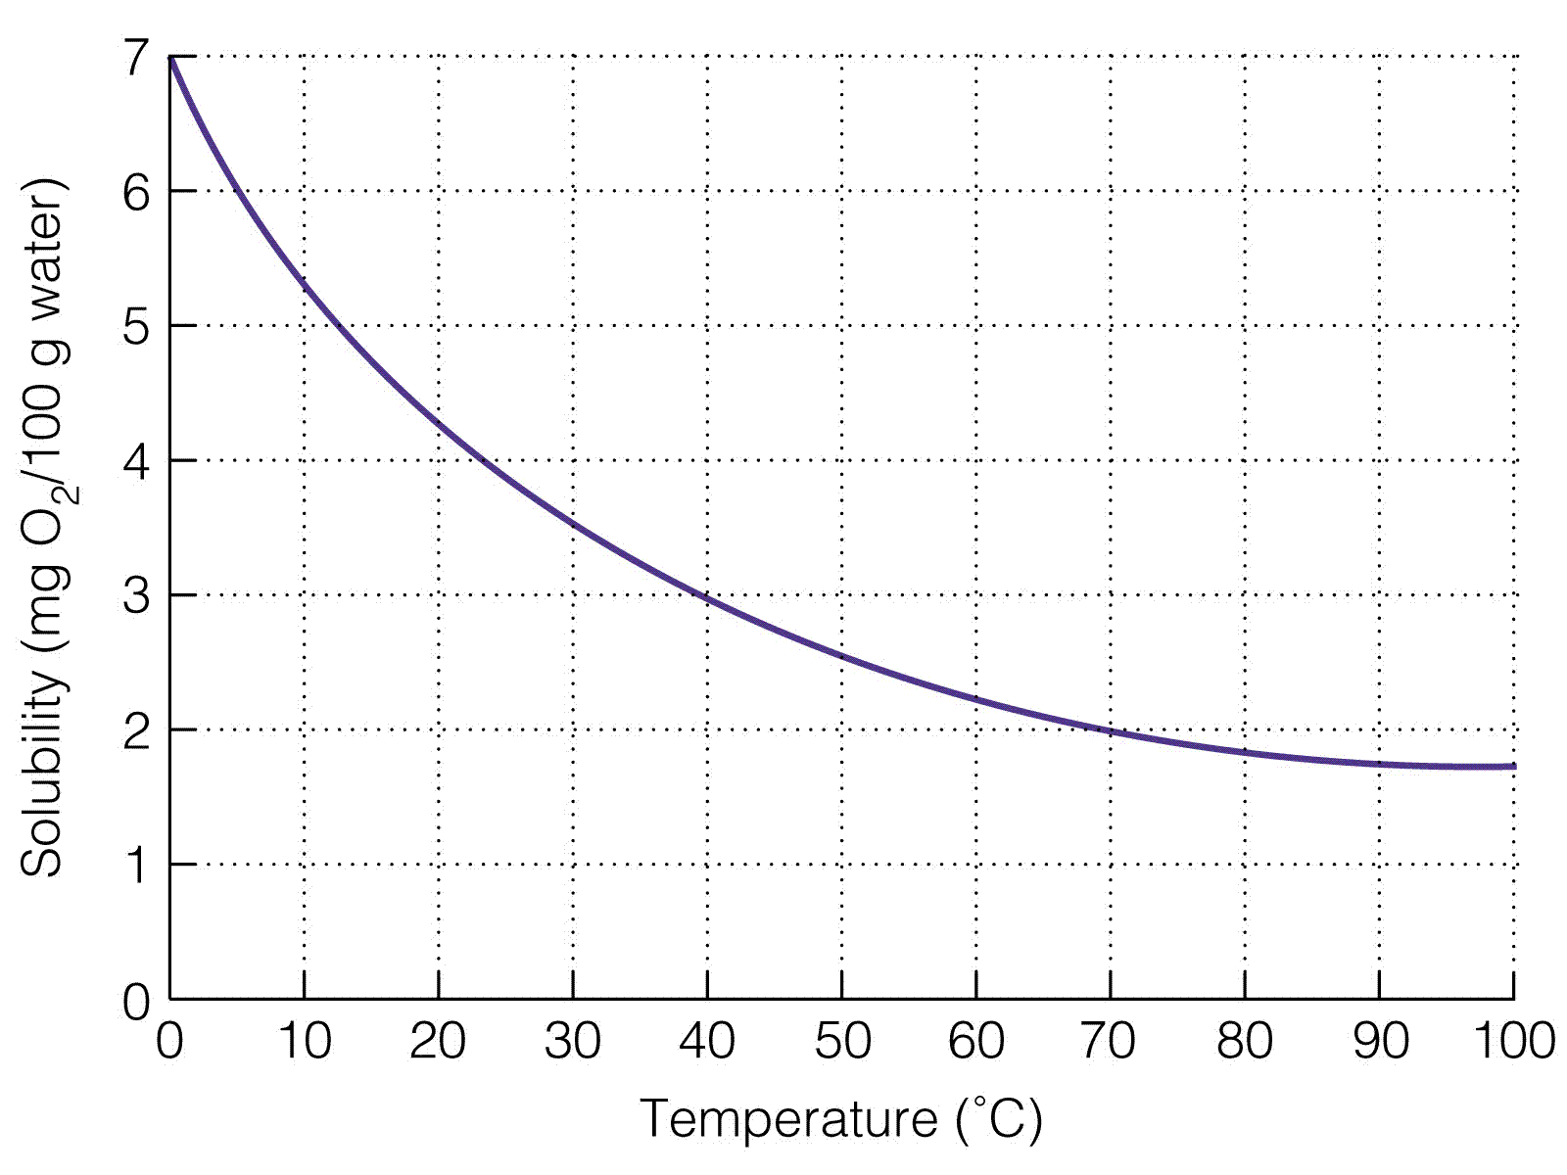
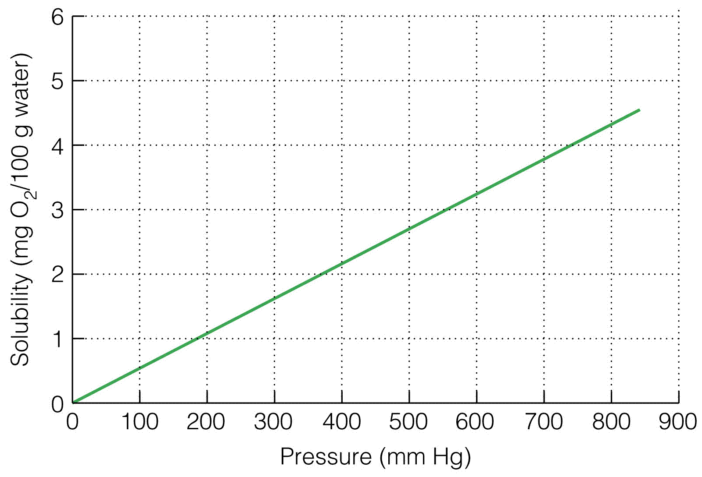

Aerators
Most intensive, recirculating aquaculture units consist of a rearing unit and some type of water treatment unit. Water flows through the rearing unit where it is contaminated with uneaten feed and fish excrement and its DO content is reduced by fish respiration. Water leaving the rearing unit passes into the treatment unit where it is purified by various physical, mechanical, and biological processes before being passed through the rearing unit again. In some places, recirculating systems are located outdoors and employ large earthen ponds as biological water-purification units. Such systems do not differ substantially from conventional pond aquaculture systems, because phytoplankton are a dominant component. The phytoplankton remove ammonia and release oxygen in photosynthesis, but they also produce large amounts of organic matter in photosynthesis. Because of low light intensity, indoor, recirculating systems do not contain a significant amount of phytoplankton. Organic matter in the system can be traced back to the feed, and the natural supply of oxygen is small.
Oxygen can be added to an indoor, recirculating system at almost any point. However, the part of the system most sensitive to low DO concentration is the rearing unit. If DO concentrations are low in the rearing unit, fish will be stressed. They will not eat and grow well, they will be susceptible to disease, and they may die.
Any place in the system where water flows abruptly to a lower elevation affords the opportunity for gravity aeration. Water may fall over a weir, fall through perforated trays, spray from a nozzle, splash over an inclined surface, flow through a container packed with porous media, etc. This type of aeration is called gravity aeration. Because head loss provides the energy for gravity aeration, there usually is no operating cost associated with it. However, gravity aerators are not very efficient, and the practice of pumping water to a higher elevation just to provide head for gravity aeration is not as economical as many other kinds of aeration (Soderberg 1982).
Recently, there has been considerable interest in pure oxygen contact systems for increasing DO concentrations in fish culture systems. In these systems, U-tubes, packed columns, spray chambers, and many other devices are used to effect transfer of pure oxygen into water which is then passed through the grow-out unit (Boyd and Watten 1989). Pure oxygen contact systems have certain advantages which will not be discussed here, but their economy is not obvious. Until more is known about operating pure oxygen contact systems, mechanical aerators seem more practical.

Principles of Mechanical Aeration
Aerators are mechanical devices that increase the rate at which oxygen enters water. There are two basic techniques for aerating pond water: water is splashed into the air or bubbles of air are released into the water. Hence, we have "splasher" and "bubbler" aerators.
Splasher aerators include vertical pump, pump-sprayer, and paddle wheel aerators. A vertical pump aerator consists of a motor with an impeller (propeller) attached to its shaft. The motor is suspended below a float with a center opening and the impeller jets water into the air at low velocity. A pump-sprayer aerator employs a centrifugal pump to spray water at high velocity through holes in a manifold and into the air. A paddle wheel aerator splashes water into the air as the paddle wheel rotates (Boyd and Ahmad 1987).
Bubbler aerators include diffused-air systems and propeller-aspirator-pumps. In a diffused-air system, an air blower or air compressor is employed to deliver air through an air line, and the air is released through air diffusers located on the bottom or suspended in the water, The propeller-aspirator-pump aerator has a high velocity, uncased impeller at the end of a hollow shaft and housing. In operation, air flows down the shaft by the venturi principle and is released into the water in fine bubbles (Boyd and Ahmad 1987).

Performance
The ability of an aerator to transfer oxygen to water is expressed as the standard oxygen transfer rate (SOTR) and the standard aerator efficiency (SAE). The SOTR is the amount of oxygen that an aerator will transfer in 1 hour to clear freshwater at 20°C which contains 0 mg/I DO. SOTR usually is expressed as pounds of oxygen per hour. The SAE is simply the SOTR divided by power input; it normally is expressed as pounds of oxygen per kilowatt~hour or pounds of oxygen per horsepower. Power input may be expressed as power applied to the aerator shaft (brake power) or the electricity consumption by the aerator (wire power); it is best for practical purposes to express SAE in terms of the rated horsepower of the aeration unit. Standard conditions employed for presenting SOTR and SAE values seldom exist in aquaculture systems. As DO concentration and water temperature rises, actual oxygen transfer rate and actual aeration efficiency decrease with respect to SOTR and SAE. For example, at 30°C and 4 mg/I DO, an aerator would transfer only about 50% of the oxygen suggested by SOTR and SAE. Nevertheless, SOTR and SAE are important for they permit comparisons of efficiency among aerators.
The nomograph, Figure 1, may be used to obtain correction factors for converting SOTR or SAE to actual oxygen transfer under pond conditions.
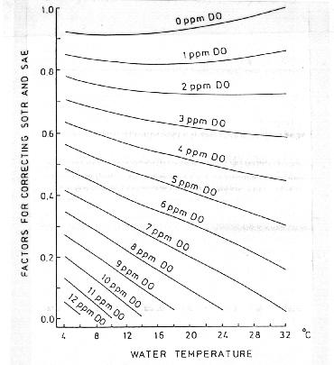

Figure 1. Nomograph for estimating correction factors for SOTR and SAE
Researchers at Auburn University evaluated the performance of many aerators and studied the effect of design features and operating conditions on performance. Results in terms of pounds of oxygen transferred per kilowatt of electrical power used are summarized below :

SAE lb O₂/hp-hr
---------------------
Aerator type Average Range
-------------- ------------ ----------
Paddle wheel, all types 3.1 1.6 - 4.3
Propeller-aspirator pump 2.3 1.9 - 2.6
Vertical pump 2.0 1.0 - 2.6
Pump sprayer 1.9 1.3 - 2.8
Diffusion 1.3 1.0 - 2.3

TABLE 2. Power requirement in HP, standard oxygen transfer rate (SOTR) in pounds of oxygen per hour, and standard aeration efficiency (SAE) in pounds of oxygen per horsepower~hour for a diffusion aeration system operated at different depths and air flow rates.

Air
Diffuser flow
depth rate Six diffusers Twelve diffusers
(ft) (ft³/min) hp SOTR SAE hp SOTR SAE
------------------------------------------------------------------
3 1 0.04 0.13 3.48 0.03 0.13 3.98
2 0.08 0.22 2.66 0.07 0.24 3.22
3 0.14 0.29 2.15 0.12 0.34 2.82
5 0.29 0.42 1.46 0.28 0.38 1.38
7 0.48 0.54 1.13 0.46 0.48 1.05
9 0.77 0.66 0.86 0.74 0.61 0.83
5 1 0.06 0.21 3.63 0.06 0.19 3.45
2 0.12 0.36 3.04 0.12 0.39 3.40
3 0.19 0.50 2.60 0.18 0.42 2.28
5 0.39 0.74 1.92 0.36 0.64 1.78
7 0.62 0.92 1.49 0.59 0.82 1.40
9 0.91 1.10 1.21 0.89 0.88 0.99
7 1 0.07 0.29 3.91 0.07 0.28 3.87
2 0.15 0.49 3.18 0.15 0.52 3.42
3 0.24 0.64 2.64 0.24 0.71 2.93
5 0.46 0.80 1.72 0.45 0.93 2.05
7 0.72 0.97 1.34 0.72 1.21 1.69
9 1.03 1.17 1.13 1.05 1.54 1.46
9 1 0.09 0.35 3.78 0.09 0.31 3.34
2 0.19 0.63 3.34 0.19 0.64 3.39
3 0.29 0.88 3.04 0.28 0.89 3.17
5 0.54 0.97 1.79 0.54 1.30 2.40
7 0.84 1.24 1.48 0.83 1.66 2.00
11 1 0.11 0.33 3.02 0.11 0.35 3.23
2 0.23 0.61 2.66 0.22 0.77 3.46
3 0.36 0.82 2.30 0.34 1.14 3.31
5 0.64 1.22 1.92 0.63 1.69 2.67
7 0.95 1.57 1.65 0.94 2.18 2.32
------------------------------------------------------------------
Although research has shown paddle wheel aerators to be highly efficient, they are too large for use in most indoor, recirculating systems. Small vertical-pump aerators, propeller-aspirator-pump aerators, and diffusion aerators are better suited for recirculating systems. SAE values for 0.5 to 2.0-hp vertical pump and propeller-aspirator-pump aerators typically ranged from 1.0 to 2.6 lb O₂/hp-hr. For design purposes, I suggest using an SAE of 2 lb O₂/hp-hr. These types of aerators are designed to operate in a set manner. They only have to be assembled, placed in the aquaculture system, and put into operation.
Diffusion aeration systems are much more complicated. Choices must be made about air pressure, air flow rate, type of diffuser, depth of diffuser, and number of diffusers. The performance of diffusion aeration systems is quite sensitive to the combination of operating variables as illustrated in Table 2 with data collected under different conditions for a particular system. Low air flow rates provided higher SAE values, and at low air flow rates depth of water over the diffuser and the number of diffusers had little effect on SAE. At higher air flow rates, SAE tended to increase with water depth, and increasing the number of diffusers enhanced SAE.
Although SAE is important for comparing aerator efficiency, other factors should also be considered in selecting aerators. These factors include: compatibility with culture system, purchase price, durability and operation lifetime, problems in obtaining service, and personal choice. Also, SAE is simply a measure of efficiency. The SOTR must be considered in determining if an aeration system is large enough to supply the desired quantity of oxygen.

Design Example
A simple way to determine the amount of fish biomass that can be supported by an aeration system will be described. Suppose that a 2-hp aeration system that has an SOTR of 4 lb of oxygen/hr is to be used in a rearing tank that receives 18°C water containing 5 mg/I DO. The aeration system should keep the DO concentration above 5 mg/I at all times. From Fig. 1, the correction factor from estimating the actual oxygen transfer rate from the SOTR at 18°C and 5 mg/I DO is 0.44. Thus, the aeration system will transfer 1.76 lb of oxygen/hr or 42.2 lb oxygen/day to the water. This is enough oxygen to permit the application of 211 lb feed/day. If fish are fed at 3% of body weight per day, the estimated maximum, permissible standing crop is 7,000 lb of fish. However, this would provide no margin of safety. I suggest a safety factor of at least 1.5 (a safety factor of 2 would be better). The maximum permissible standing crops of fish would be 4,700 lb and 3,500 lb for safety factors of 1.5 and 2, respectively.
Chemical Calculations
The three states of matter we experience in our everyday lives are solid, liquid and gas. Water is present, depending on where you live and the time of the year, in all three phases. Phase interactions are the basis of much of the interesting chemistry that shapes our planet. Dissolved oxygen in water makes it possible for fish and insects to live underwater. The oxygen in the atmosphere originated from microorganisms that lived in the sea. The transfer of oxygen from the sea to the atmosphere mad e it possible of life to develop on the land.
Phase interactions are responsible for the transport of nutrients (and pollutants) in soil, and the formation of all the sedimentary minerals. The earth is unique among bodies of the solar system, in that it has oceans of liquid water. The phase inte ractions that result from the oceans stabilize the earth's temperature and move water to the land where it condenses as fresh water to support both plant and animal lifeforms. An understanding of phase interactions is essential to understanding the chemical processes of the environment. Figure from Manahan illustrates many of the important phase interactions for environmental chemistry.
Important environmental chemical processes that involve liquid water with dissolved gases and solids.
To examine the role that dissolved gases play in the environment, let's re-examine the solubility of calcium carbonate in water. In a sealed bottle containing only pure water and pure calcium carbonate, we find the following :

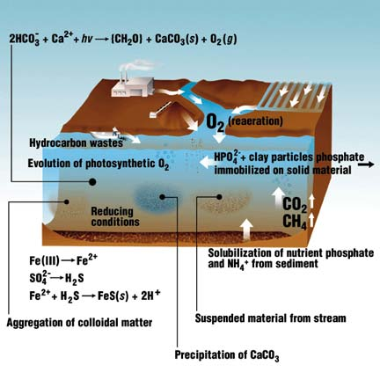
Equilibrium conditions for CaCO₃ in water, closed to the air:
pH = 9.95 and the [Ca²⁺] = 1.26 x 10⁻⁴
Equilibrium conditions for CaCO₃ in water, open to the air:
pH = 8.40 and the [Ca²⁺] = 3.98 x 10⁻⁴
The pH drops over 2.5 pH units and the calcium concentration increases by over three times by exposing calcium carbonate to atmospheric carbon dioxide. This occurs because of the following reactions:
CO_{2(g)} + H₂O → H₂CO₃
H₂CO₃ + CaCO₃ → 2 HCO₃⁻ + Ca²⁺
The two relationships that govern the amount of gases that dissolve in water are Henry's Law and Dalton's Law of Partial Pressures.
Henry's Law: [X_{(aq)}] = K_{H} P_{X}
Dalton's Law of Partial Pressures: P_{T} = P₁ + P₂ + P₃ + P₄ + · · · ·
For the dissolution of oxygen in water open to the air, the problem would be worked in this fashion:
P_{ATM} = P_{N2} + P_{O2} + P_{H2O} + P_{CO2} + · · · ·
Since air is 20.95% O₂, we can write:
P_{O2} = (0.2095)(P_{atm} - P_{H2O})
And the solubility of O₂ in water is: [O_{2(aq)}] = K_{H} P_{O2}
Calculate the solubility of oxygen in water at 25 ° C, open to the atmosphere at 1.0 atm (760 mm/Hg) of pressure:
Vapor pressure of water at 25 ° C is 23.456 mm/Hg (from Handbook)
23.456 mm/Hg x 1.000 atm/760 mm/Hg = 0.031 atm
P_{O2} = 0.2095(1.000 - 0.031) = 0.2030 atm
[O_{2(aq)}] = K_{H}P_{O2} = (1.28 x 10⁻³ mol/L-atm)(0.2030 atm) = 2.60 x 10⁻⁴ mol/L
The Henry's Law constant only applies at the temperature specified. To determine the solubility of gases at different temperatures, you must use the Clausius-Clapeyron equation. First, the solubility of the gas is calculated for the temperature speci fied for the Henry's Law constant. Then, use the Clausius-Clapeyron equation to calculate the solubility at the new temperature. The enthalpies for dissolution of the gas must be known to use the Clausius-Clapeyron equation. Henry's Law constants, at 25 ° C, and enthalpies of dissolution are given for common gases in the table below :
Henry's Law constants and enthalpies of dissolution for common gases at 25 ° C.
Gas | K_{H} | Δ H
CO₂ | 3.38 x 10⁻² | -5,242 cal
CH₄ | 1.34 x 10⁻³ | -3,970 cal
H₂ | 7.90 x 10⁻⁴ | -1,208 cal
N₂ | 6.48 x 10⁻⁴ | -2,973 cal
O₂ | 1.28 x 10⁻³ | -3,500 cal

The Clausius-Clapeyron equation is :

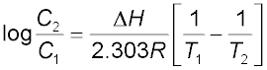

What would be the oxygen concentration of water saturated with air at 10 ° C?
C₁ = 2.60 x 10⁻⁴ mol/L x 32.0 g/mol = 8.32 x 10⁻³ g/L = 8.32 mg/L
T₁ = 25 ° C = 298 K
T₂ = 10 ° C = 283 K
C₂ = ?
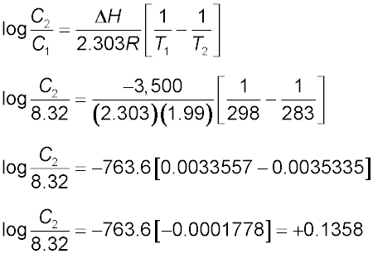
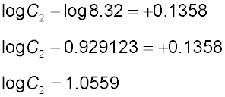
C₂ = 11.4 mg/L
Note that the solubility of gases is greater at lower temperature. This is because the enthalpy of dissolution for gases in water is negative.

