Abstract
Properly sized and operated airlift pump systems will reliably move water to minimize stratification even in 20-A ponds. Their simplicity, low cost, and effectiveness makes airlift pumps especially suitable for use in water reuse systems and hatchery operations. Basic components of an airlift pump system typically include a regenerative or sliding vane blower, an air distribution system of polyvinylchloride pipe, tubing to pipe adaptors, tubing, orifices to control delivery of air, and airlift pumps arranged as single units or in parallel as panels.

Introduction
Airlift pumps have been used to move liquids since at least 1797 (Ivens 1914). Small water reuse systems such as aquaria for hobby fish use airlift pumps to move water through the filter system. The simplicity of airlift pumps makes them a first choice for use in aquaria (Castro 1975, Spotte 1979). However, maintaining an even flow of air and water from multiple pumps connected to a common air source has been a problem. The water flow is usually adjusted with a series of small valves which control air delivery to individual pumps. In larger systems it is difficult to properly balance air flow with a series of valves, but, systems properly designed with fixed orifices to regulate airflow will work reliably. The objective of this paper is to describe construction and operation of airlift pumps for aquaculture and specifically for use in recirculating systems.

Components

Air pump
An airlift system requires a pump or blower to deliver air, a series of tubes and pipes for air distribution, a valve or orifice to control air flow, and a vertically mounted tube as the actual airlift pump. In very small systems, such as in one or two aquaria, air is commonly supplied by diaphragm-type pumps. However, in larger systems either regenerative or sliding vane-type blowers are preferred (Parker 1983). Due to the very shallow depth (3-6 ft.) of most aquaculture facilities it is not necessary to provide air at high pressure; instead, it is more efficient to deliver a larger volume of air (60 cfm/hp) at a relatively low (less than 1 psi) pressure.

Air distribution
Moving large volumes of air at low pressure requires relatively large diameter pipes. For systems installed on ponds, 3-, 4- and 6-inch diameter lines are commonly used for the main distribution with smaller diameter pipes (2-inch) as laterals. The actual pipe diameter required i s a function of the length and number of bends in the line. As a rule of thumb, when a regenerative blower is hot enough to burn your hand then insufficient air is passing through it. Air passing through the blower will keep it cool and the pipes in the air distribution system will remain cool if properly sized and operated. For smaller systems such as those in a hatchery building or laboratory a 2- or 3-inch pipe will be adequate for the main distribution line with laterals of 0.5- to 1-inch pipe.

Connecting tubes
For larger systems, airlifts of 3- or 4-inch diameter are connected to the main distribution line or laterals by 0.5-inch tubing. Black coiled polyethylene tubing of 0.5-inch diameter is commonly used, However, garden hoses and clear vinyl tubing such as tygon tubing are very adequate. On smaller systems with airlifts of 2-inch diameter or less the clear vinyl tubing of 0.25- to 0.5-inch is preferred. These connecting tubes should be as short as possible to minimize friction and back pressure.
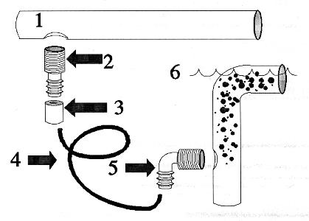

Figure 1.Connection of components for an airlift pump: (1) PVC pipe for air distribution from the air pump or blower; (2) male thread by slip-fit tubing adapter and (3) plug with orifice; (4) airline tubing; (5) 900 tubing adapter and (6) airlift pump in operation indicating optimum placement for maximum water flow and presence of air bubbles in the body of the airlift. (Drawings not to scale).
Pipe-to-tubing connectors
Valves are not needed in a properly designed air delivery system. Air flow is regulated by properly sizing the components and by use of orifices (Item 4, Fig. 1) to restrict air flow from the system. When schedule 40 polyvinylchloride (PVC) pipe is used for the air distribution system connections for tubing can be made by drilling and taping the PVC pipe (Item 1, Fig 1) to accept male tubing adapters (Item 2, Fig. 1). An orifice placed in the tubing connector at the distribution pipe will regulate air delivery to the airlift pump. Orifices have been made by plugging the tubing connector with a short segment of PVC rod or other material (wood, steel, or other plastics) and then drilling a small hole usually 1/16 to 1/4-inch diameter in the plug. A set of small drill bits ranging from 1/64 to 1/4 inch with size gradations of about 0.015 to 0.070 inch are useful for drilling the orifices. These drills are known as wire size drills and a number 80 drill bit is 0.0135 inches in diameter whereas a number 1 drill bit is 0.2280 inches.

Airlift pumps
The body of the airlift pump is usually a 1- to 4-inch diameter PVC pipe. Small diameter airlifts move more water per volume of air injected than large diameter airlifts (Parker and Suttle 1987). In ponds airlift pumps 3 inches in diameter are preferred whereas in tanks airlifts of 1 to 2 inch diameter are commonly used. The airlifts are constructed from a piece of PVC pipe fitted with a 900 elbow at the top, a means for attachment, and a port for injection of air. Alternately, heavy-walled PVC and polyethylene pipes cut on a 450 angle have been reassembled and welded to form a 900 bend at the upper end. Diffusers have proven to be of limited value due to the problems of fouling and are not recommended.
Several small diameter airlifts placed side-by-side (Fig. 2) or constructed from parallel tubes (Fig. 3 and 4) in a panel will pump more water than will a single large diameter tube. The air and water are more uniformly mixed in small tubes but separate to form a two-phase flow in large tubes. The low density air slips around the high density water in large pipes resulting in substantial noise but little water movement.
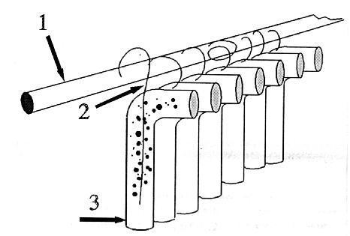

Figure 2.Airlift tubes arranged side-by-side showing (1) air distribution line from air pump or blower, (2) tubes connecting airlift pumps to distribution line, and (3) airlift pumps with bubbles depicted in the first tube.
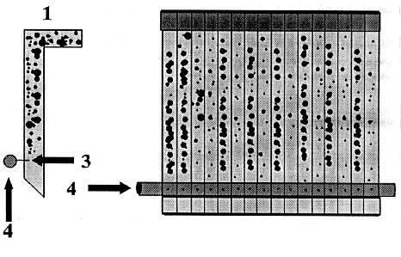

Figure 3.A pond airlift (1) end view, (2) front view, (3) point of air injection into the pond, and (4) Air delivery line Note internal partitions in the panel to minimize side-to-side slippage of air and water.

Installation of an airlift system

In ponds, airlifts are usually placed along one side and one end, preferably the deep end to establish a circular flow throughout the pond. Ten, 3-inch diameter airlifts per acre have been used to eliminate stratification in ponds (Parker and Suttle 1987). Each airlift received 3 cfm of air and pumped about 55 gpm. A 1-hp regenerative blower will operate 20 airlifts at 30 inches of water pressure. To minimize hardware distribution throughout the pond, airlifts have been arranged in groups of five to ten and supplied with air from a 2-inch lateral line branching from the main distribution line.
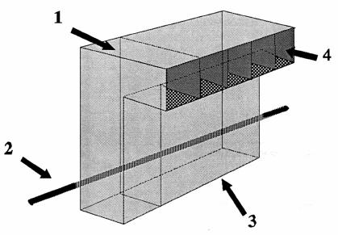

Figure 4.Three dimensional view of a panel air lift: (1) one internal partition shown; (2) air delivery line; (3) water intake port and (4) water discharge port.
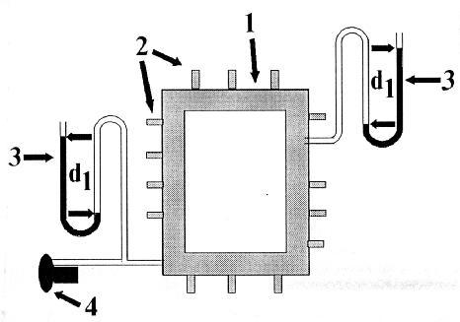

Figure 5.Air distribution system arranged in a box-type pattern to equalize air pressure throughout the system: (1) main air distribution line; (2) outlets for airlifts (or air stones in small tanks); (3) water manometers indicating equal pressure (d1) on front and (d2) on back side of system and (4) blower providing pressurized air for the system.

Air distribution for indoor systems is commonly arranged in a box-type pattern (Fig. 5) running around the walls of the building with laterals branching to the interior areas. This arrangement facilitates placement of air outlets along the walls or in tanks and provides relatively uniform air pressure as needed. Alternately a central main line down the center with laterals to the sides works very well but air pressure may be less uniform than with the box-type distribution system (Fig. 6).
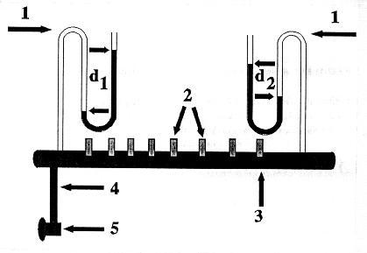

Figure 6.Air distribution system with a single straight manifold: (1) water manometer indicating high pressure (d1) at the head end of the manifold and low pressure (d2) at the tail end of the manifold; (2) outlets for air pumps (or air stones in small tanks) (3) main distribution line or manifold; (4) discharge line from air pump or blower and (5) air blower.
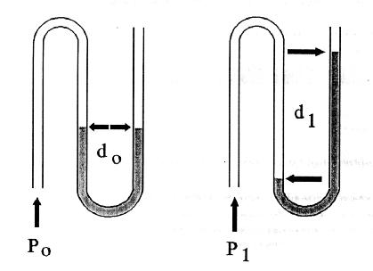

Figure 7.Water manometers constructed of vinyl tubing and half filled with water: (Po) no air pressure applied (blower is off) and there is no difference (do) in the height of the water column in the U-shaped manometer, (P1) air pressure is applied (blower is on) and water columns are different heights. This difference, dl, is typically measured in inches and reported as inches of water pressure.

Pilot Systems
The low pressure required to operate air lift pumps makes them easy to assemble and test prior to final installation. Hub-type connections on PVC pipe can be slipped together without glue and will usually stay together due to friction long enough to conduct preliminary test of a system. If a fitting does separate, it can be temporarily held together with tape or by drilling a small hole through the pipe and coupling for insertion of a nail or small screw. Before installing a permanent system, it is recommended that a pilot system be evaluated to become familiar with the principals of regulating low pressure air in aquaculture. Pilot systems have ranged in size from a 10-hp regenerative blower delivering air to airlifts in a 20-A pond down to very small systems using a discarded automobile smog pump (a sliding vane pump) providing air for a few tanks or aquaria. Once the principles are understood and the pilot system is operating properly the component parts can be permanently assembled.
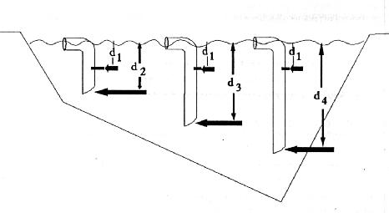

Figure 8.Placement of airlifts to lift water from various depths in a pond or tank. Note: the point of air injection (dl) is constant for all airlifts even though the length of the lift tube varies from short (d2, shallow) to long (d4, deep).

Operation
The number of air outlets on a system (e.g. the number of airlift pumps which can be operated) is a function of the internal resistance (friction loss of pressure) in the system and the water depth at which air is injected If the maximum depth of air injection is 24 inches then the air pressure in the distribution line must be at least 24 inches of water (0.8 psi); however air at 30 inches of water pressure is preferred. Water pressure IS easily measured with a water manometer (Fig 7) constructed from a piece of clear vinyl tubing looped into a large U shape and half filled with water. Tubing of 1/8 and 1/4 inch diameter is commonly used for manometers and can be connected to PVC pipe by drilling, taping and inserting a 1/4-inch male thread tubing adapter. When not in use the 1/4-inch threaded hole can be plugged. A properly sized and constructed air delivery system for air lift pumps will maintain a constant pressure of about 29-30 inches in the distribution line even when all airlifts are removed from the water. The orifices, not the depth of water, regulates the pressure. To lift water from deep tanks or ponds the length of the airlift tubes may vary (Fig. 8) but the point of air injection must remain constant. When an air outlet is not being used it should remain open to exhaust air through the orifice. If the outlet is blocked the pressure in the distribution line and the back pressure on the pump is increased. The increase in pressure is accompanied with an increase in temperature and high temperature contributes to failure of bearings in the blower and motor.

