BIOFILTERS
There is considerable confusion concerning the term biological filtration, because it can mean different things to different people. Biological filtration will be used in this paper to mean the process by which ammonia is first converted to nitrite and then to nitrate. This process is also called nitrification. Other papers given at this workshop cover the microbiology of the nitrifying bacteria. Hence, this paper will concentrate on filter design considerations. It should also be noted that anyone can construct a biofilter. After all, a simple biofilter is nothing more than some solid particulate media held in a container over which water containing waste is pumped. The challenge to the designer is to produce a biofilter that removes the ammonia and nitrite at the required rate, requires little maintenance, is cost effective and efficient, and is integrated into the system in which it is operating. Designing a biofilter to meet all of these requirements is not a trivial exercise.

Filter Configurations
There are five general filter configurations commonly used in aquaculture production systems: submerged, trickling filters, biodisks, biodrums, and fluidized beds.

Submerged Filters
Figure 1 shows a schematic diagram of a submerged filter. The filter consists of a container filled with porous media. Water enters the filter, passes over the media on which the bacteria grow, and out of the filter. The media may be almost any material that will allow the water to pass through easily and is non-toxic to the nitrifying bacteria that grow on the media surface. Some of the more common media types include rock, sand, and plastic media of various designs. The inflow and outflow must be designed to handle both the normal flow through the filter and the backwash flow. Because the backwash flow is considerably higher than the normal flow, it usually determines pipe size.
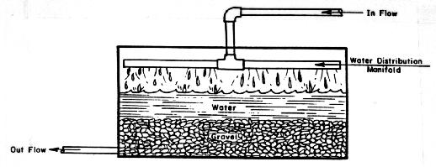

Figure 1. Schematic diagram of a submerged downflow biofilter.
The distinguishing feature of a submerged filter is that the media is always submerged completely below the water surface There are two common operational modes for submerged filters. When the water flows from the top of the filter downward and out the bottom filter it is called a downflow filter. When water flow is from bottom to top it is referred to as an upflow filter. Occasionally submerged filters are operated such that water flows horizontally through the filter. This mode is called a cross flow filter.

Trickling Filters
Trickling filters look the same as a submerged filter except the media are kept damp, but not submerged. Wastewater is allowed to trickle down through the filter, but the flow is maintained low enough that the media is not flooded. This allows air to circulate through the filter at the same time as the wastewater is moving downward through the filter.

Biodisks
Figure 2 shows a schematic drawing of a biodisk. The filter is composed of a series of circular plates each of which is attached to a common shaft. Plate spacing along the length of the shaft is minimized while maintaining enough space for wastewater to circulate between plates after a bacterial film has been established on both sides of each plate. The shaft passes through the center of each plate and is mounted in bearings attached to each end of the wastewater container. The mounting is located such that the plates are submerged in the wastewater to approximately one-half of their diameter. The shaft and plates attached to it are rotated by a power source, usually an electric motor. Flow through a biodisk is usually parallel to the shaft.
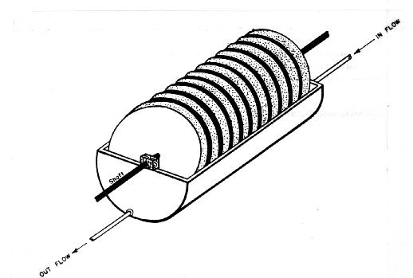

Figure 2. Diagram of a biodisk.

Biodrum
Figure 3 shows a schematic of a biodrum. Biodrums look and operate similar to a biodisk except the disks are replaced by a cylindrical drum. The cylindrical drum surface is porous, typically some type of mesh material, and the drum is filled with some type of solid media having a high specific surface area (area of all of the pieces of media in the drum) per unit volume. Plastic media, such as plastic rings or balls, are usually used as media rather than rock (which is heavy) to reduce drum weight and, hence, the structural support needed for the drum.
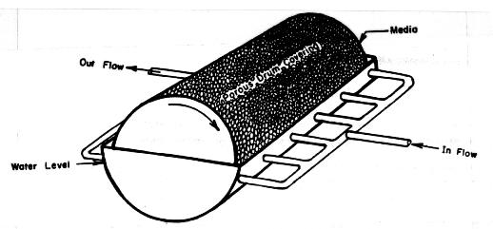

Figure 3. Biodrum schematic diagram.

Fluidized Beds
Figure 4 shows a schematic of a fluidized bed filter. The filter consists of a closed container that is partially filled with a particulate media, typically sand. Wastewater enters the filter through the bottom, passes through a distribution plate, moves through the media and exits from the top of the filter.
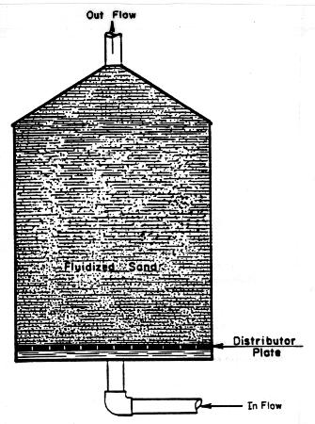

Figure 4.Schematic diagram of a fluidized bed biofilter.
The distribution plate serves two functions; 1) it supports the media and prevents it from clogging the inlet when the filter is not operating, and 2) it helps distribute the wastewater evenly across the horizontal area of the filter. During operation sufficient water flow is maintained to suspend the media particles in the upward flow. This is called fluidizing the bed and is the reason these filters are referred to as fluidized beds. Too low a water flow rate will not fluidize the bed, while too high a flow rate will flush the media out of the filter. Nitrifying bacteria grow on the fluidized particles and remove ammonia as it moves past.
A bead filter, Figure 5, is a special form of a fluidized bed. In bead filters the media consists of small plastic beads, typically less than 2-4 mm in diameter, that float. The beads are held in the container by a screen at the outlet and the water passes upward through the bed of beads. The filter is cleaned by stirring the beads mechanically (with a propeller), by the use of air released into the water stream, or by closing down the flow and letting the beads fall to the bottom of the container. The solids trapped in the beads are washed out during cleaning and discarded.
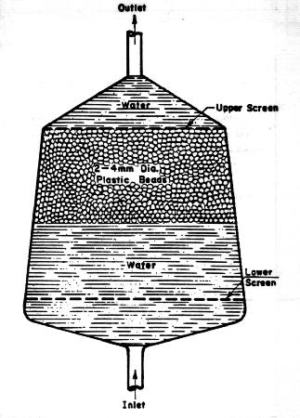

Figure 5. Schematic of a bead filter.

Comparison of Filter Types

Oxygen Supply
The water passing through the filter is the only oxygen source for the bacteria in a submerged filter. This is a major design constraint on submerged filters, because water flow rate is often determined by the bacteria's oxygen demand. Filter oxygen demand is high, sometimes exceeding that of the cultured crop. Oxygen supply in trickling filters, biodisks, and biodrums is primarily from the air. Air contains 210,000 ppm of oxygen while cool, oxygen saturated water contains less than 15 ppm of oxygen. This large oxygen concentration difference between air and water is why it is much easier to supply filter oxygen demands from air contact than by water flow. Fluidized bed filters and bead filters require a relatively high water flow rate to fluidize the bed. Thus, the water flow is usually more than sufficient to supply the needed oxygen.
Oxygen availability to bacteria in rotating biological contactors (RBC's), including biodisks and biodrums, depends on rotational speed of the RBC. Selection of proper rotational speed will assure that the bacteria do not dry out while out of the water, nor do they run out of oxygen while they are in the wastewater. Maximum RBC rotational speed is limited by the bacteria scour velocity. At some velocity, the scour velocity, friction between the water and the media is great enough to strip the bacteria layer off the filter media. Obviously, peripheral disk or drum velocities that exceed the scour velocity will destroy the nitrifying capability of the RBC.

Energy Usage
Energy requirements of biofilters is an important concern in aquaculture. Energy requirements in submerged and trickling filters are primarily due to pumping water vertically into or out of the filter. Submerged filters can, if designed correctly, operate with from less than one to a few psi (pounds per sq inch) pressure drop across the filter, Trickling filters usually require pumping the water the full height of the filter. Thus, the taller the filter the more energy consumed during operation.
Energy consumption in RBC's is essentially the power required to rotate the RBC. The faster the RBC is rotated, the higher the energy consumption. Increased rotational speed generally increases mixing in the tank containing the RBC. Increased mixing is sometimes desirable because it increases aeration and/or suspension of solids. However, increased mixing increases energy consumption by the RBC. Thus, a design compromise must be made between increased mixing and/or aeration by the RBC and minimizing energy consumption. The pressure loss across an RBC is very low, usually in the range of 1 inch or less of water.
Fluidized bed filters require relative high water velocities to fluidize the media. Energy loss due to the water flowing through a pipe or filter increases with the square of the velocity. Thus, doubling the water velocity through the same pipe increases the energy loss by four times. A similar energy loss is experienced when water velocity through a filter increases. Thus, a designer must balance energy usage against other desirable features of a specific filter.
Bead filters generally have fairly high water velocities through them. Thus, energy consumption in these filters is primarily due to pressure loss through the bead bed.

Clogging
Filter clogging is undesirable, because it restricts water flow through the filter. Restricted water flow reduces filter ammonia removal capacity, may cause the filter to run over, and almost surely will cause oxygen starved areas to develop in the filter. Oxygen starved, anaerobic, areas produce hydrogen sulfide and other toxic and smelly compounds that can cause direct fish kills in the system. Clogging also increases energy loss across the filter which can lead to increased operating costs.
Clogging is caused by an accumulation of organics, dead bacteria, and other particulate debris in the porous passages in the filter. Downflow submerged biofilters are probably most subject to clogging of any of the biofilter designs. Upflow submerged filters and bead filters exhibit somewhat less clogging followed in order by fluidized beds, biodrums, and biodisks. Upflow and downflow submerged filters, bead filters, and fluidized bed filters are designed to facilitate periodic backwashing to remove the accumulated particulates. Biodrums and biodisks rarely clog.

Sludge Disposal
All biofilters produce some solids, primarily dead bacteria cells. The amount of sludge produced by the various types of filters is essentially the same, although the particle size and or shape may be different. This material must be removed from the system or it will increase the oxygen demand of the wastewater.

Filter Break-In
Biofilters are essentially masses of living organism, primarily bacteria of several species. As such, the filter does not react instantaneously to changes in the environment. Ammonia loading on a filter (i.e., pounds of ammonia entering the filter per day) is the environmental parameter of most interest to culturists. When the ammonia load increases, due to an increase in the number of animals in the system or an increase in the amount of feed fed, the filter requires time to adjust to the new conditions. The amount of time depends on the rapidity and the magnitude of the change, the more rapid or the greater the loading change the longer time is required to restabilize the filter. Changes in other environmental parameters (e.g., temperature) will have similar effects.
Figure 6 shows what are termed break-in curves for a new biofilter. These curves demonstrate the lag in response of a biofilter to a loading change. In the case shown in Figure 6, a constant load is placed on a new filter. The load can be generated by placing some fish in the system, by daily feeding of ammonia chloride or other means. The ammonia concentration first starts to increase because ammonia is continuously being added to the system, but there is no bacteria to remove it. The ammonia provides a plentiful supply of food so nitrifying bacteria that usually are ubiquitous in the environment attach themselves to the filter media and thrive. However, it takes many bacterial generations to produce a large enough bacteria population to consume the ammonia faster than it is being added to the filter The time required for the bacteria to reproduce results in a lag between a loading change and restabilization of a low ammonia concentration. At some point the population of bacteria that convert ammonia to nitrite, Nitrosomonas, is great enough that ammonia consumption exceeds ammonia production. The ammonia concentration falls to a low level, but the level of nitrite increases due to its production by Nitrosomonas. The plentiful supply of nitrite encourages growth of Nitrobacter, the genus of bacteria that converts nitrite to nitrate. As the Nitrobacter population increases the nitrite concentration begins to fall as it is being consumed at a greater rate than it is being produced. Once the nitrite concentration falls to a very low value, the filter is considered to be broken-in or conditioned. The nitrate concentration in the system will slowly increase with time unless there is some means incorporated into the system to remove it (e.g., a denitrification system).
The break-in process in a new filter usually requires 30 to 60 days. In some systems the ammonia concentration may fall after a few days, but the nitrite peak may persist for a month or more. In other systems it may take much longer for the ammonia peak to pass. Researchers do not completely understand why there are such differences in the break-in pattern from one filter to another. Thus, when breaking-in a filter it is imperative that both the ammonia and nitrite concentrations be monitored to determine when the filter is broken-in.
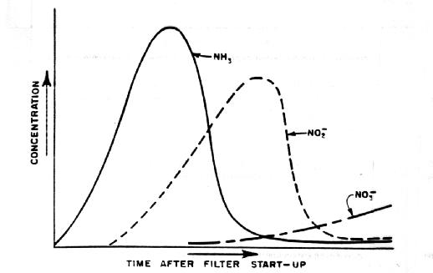

Figure 6. Typical start-up curve for various nitrogen forms in a biofilter.
There is a considerable volume of literature discussing the merits of adding "seed" to the filter to decrease the time required for break-in. Many of the results are variable. However, it appears that in new filters adding 10-30 percent or more media from an operating biofilter will decrease the break-in time drastically, sometimes as much as 60 to 90 percent (Carmigaina and Bennett, 1977; Bower and Turner, 1981; Hochheimer and Wheaton, 1991). However, both the broken-in filter and the new filter must be operating under similar environmental conditions in order for the addition to be effective. For example, using media (and bacteria attached to it) from a filter operating in a saltwater system as seed in a filter that will be operating with fresh water will not decrease the break-in time. The use of commercially available dry or wet "seed" formations has shown variable results. Although the reason for the variable results is not clear, it probably is related to the differences in the environmental parameters under which the "seed" was grown compared to the conditions in the specific filter being tested.

Biofilter Design

Design Date
Biofilter design requires some knowledge of the other components of the culture system. For example, what aeration system, what solids removal methods, and what arrangement of the system components will be used in the overall system. This data impacts on the operating conditions of the biofilter and will, thus, influence its design.
There is also a body of data needed that details the water quality requirements acceptable to the species being cultured. Acceptable ranges of pH, temperature, ammonia concentration and other variables must be known. The largest weight of fish the filter will support at any time during the life cycle of the crop must be determined. Feed to be used and feeding rates anticipated, water temperature and range of water temperatures expected, and the range of oxygen demand by the fish all need to be determined prior to designing a biofilter. Waste production rates by the particular fish species are also needed for the range of fish sizes expected in the culture system. This should include solids production as well as ammonia production.
Design of any filtration system is based on the principle that the filter must remove wastes at or above the maximum rate at which the crop produces them. If the production system has sufficient volume of water in it, there is some potential for short term (i.e., a few hours) waste removal rates to be slightly less than the hourly maximum production rate. However, filters should almost always be designed for the maximum short term ammonia production rates.

Filter Design Example
Problem -- Design a biofilter to remove the ammonia produced by 10,000 pounds of trout held in a recycled system having 95 percent recycle of water. The trout average 2.2 pounds each at the time the filter will experience the maximum ammonia load. Assume the following information :

System temperature is constant at 54°F (12° C)
Make up water has an ammonia concentration of 0 mg/L

Filter media data

Media type Plastic rings
Media diameter 2 inch
Void fraction 0.9
Specific surface area 50 ft²/ft³
Weight 2 lbs/ft

Length of a 2.2 lb trout 18.5 inches (Manual Fish Culture, 1970)

Fish feed will be trout pellets 2% body wt. per day

Minimum oxygen concentration leaving filter 5 mg/L = 5 ppm

Solution

I. Ammonia Production (AP) From Liao and Mayo (1974) :

AP = 0.0289 (Feed fed/day)

AP = (0.0289)(10,000 lbs)(2% body wt/day)

AP = 5.8 lb ammonia produced/day

II. Ammonia Removal By the Filter (AR) From tables in Speece (1973) or Wheaton (1977) : At 54°F (12°C) ammonia removal = 0.00012 lb/ft² day

III. Specific Surface Area Needed (SSA) if Have Only One Pass System

ammonia produced
SSA = -------------------------
ammonia removed/ft² day

5.8 lb/day
SSA = ---------------------
0.00012lbs/ft² day

SSA = 48,333 ft²
Note that this method of determining SSA does not account for recycling, retention time and other filter variables.

IV. Calculate Oxygen Consumption of Fish From Liao (1971) :

O_{c} = K₂TªW^{1b}

Where O_{c} = oxygen consumption rate in (lb 02/100 lb fish day), K₂ = rate constant T = temperature (°F), a,b = slopes, W = fish size (lb/fish).

The constants K₂, a and b come from tables in Liao (1971) or Wheaton (1977).

O_{c} = 3.05 x 10⁻⁴ (54)^{1.855} (2.2) ^{-0.138}

O_{c} = (3.05 x 10⁻⁴) (1635) (.9)

O_{c} = 0.4472 lb O₂/100 lb fish day

The total oxygen demand by the fish is :

O_{TOTAL} = (0.4472 lb O₂/100 lb fish day)(10,000 lb fish)

O_{TOTAL} = 44.72 lb O₂/day

V. From Liao et al. (1972) The Carrying Capacity Can be Calculated.

0.14(C_{e} - C_{m})
L_{c} = ------------------
O_{c}

Where ; L_{c} = carrying capacity (lb fish/gal/min), C_{e} = dissolved oxygenconcentration at temperature T and altitude E₁ (ppm), C_{m} = minimum oxygen concentration allowable in the filter (ppm), O_{c} = oxygen uptake rate (lb O₂/100 lb fish day).

Assume oxygen saturation is 10 ppm from tables and minimum oxygen concentration is 5 ppm (given).

1.2 (10-5) ppm
L_{c} = --------------------------------
0.447 lb O₂/100 lb fish day

L_{c} = 13.4 lb fish/gal/min

Required water flow rate (U) :

10,000 lb fish
O = -----------------------
13.4 lb fish/gal/min

O = 746 gal/min

VI. Initial Ammonia Concentration at Discharge Point

ammonia produced/day
C_{i} = ----------------------------
flow rate/day

5.8 lb ammonia/day
C_{i} = ----------------------------------------------------------------
(746 gal water/min) (60 min/hr) (24 hr/day) (8.33 lb/gal)

C_{i} = 0.65 x 10-6 lb ammonia/lb water

C_{i} = 0.65 ppm

Allowable ammonia concentration (C₂) is 0.75 mg/L (Liao et al., 1972) or 0.75 ppm.

VII. Allowable ammonia concentration factor due to recycling is:

C₂ 0.75
C = ---- = ----- = 1.15
C_{j} 0.65

VIII.The Filter Efficiency Needed to Remove the Ammonia

Produced can be Calculated from Liao et al. (1972).

1 + CR - C
E = ---------------
CR

Where ; R = percentage (as a decimal) of water recycled, E = percentage (as a decimal fraction) of metabolite removed by a single pass through the filter, C = concentration of metabolite at any rearing unit outlet divided by concentration occurring at rearing unit outlet in a single pass system (ammonia concentration factor).

1 + 1.15 (.95) - 1.15
E = -------------------------
1.15 (.95)

E = 0.86

Therefore, the filter must be 86% efficient, a rather severe requirement for a filter.

IX. Total Ammonia Load on the Filter (W_{A}) is higher than a one pass system because of recycling.

W_{A} = (ammonia load from single pass) C

W_{A} = (5.8 lb ammonia/day) 1.27

W_{A} = 7.37 lb ammonia/day

X. Filter Retention Time Needed to Achieve an Ammonia Removal of E is Given by (Liao et al., 1972).

Ep
t_{m} = ---------------
9.8 T - 21.7

t_{m} = filter retention time (hours)
E = filter efficiency (in percent)
T = water temperature (0C)

86
t_{m} = ------------------- = 0.90 hours
(9.8) (12) - 21.7

t_{m} = 53.8 min

XI. Volume of Filter Needed is :

Vol = O t_{m} (I/void ratio)

Vol = (746 gal/min) (53.8 min) (1/0.9)(0.1337 ft³/gal)

Vol = 5962 ft³

XII. Specific Surface Area is Thus :

SSA = (Vol) (surface area/unit vol)

SSA = (50 ft²/ft³)(5962 ft³)

SSA = 298,100 ft²
The above SSA was found using a calculated retention time and filter efficiency after the method developed by Liao and Mayo (1974). Compare this with the Specific Surface Area (SSA) calculated in step three of the problem. This SSA was calculated assuming an ammonia production rate and an ammonia removal rate with no recycling. The production was calculated using data from Liao et al. (1972) and the ammonia removal from data by Speece (1973). The difference in SSA needed by the two techniques is 298,100 ft² versus 48,333 ft². Converting this to volume using 50 ft²/ft³ gives a volume of 5962 ft² versus 967 ft³, a difference of over 6 times. In looking at the size of these differences it is important to realize that data for trout and catfish is very good compared to available data for other species.

XIII.Calculate filter dimensions

Using a 6 ft depth for the filter (assumed value based on the media specified)

Vol = (depth) (length) (width)

5962 ft³ = (10 ft) (length) (width)

596 ft² = (length) (width)

Assume a length of 15 ft

then width = 40 ft

XIV. Check Oxygen Supply to the Filter

Stoichiometric oxygen requirement is 4.57 lb oxygen/lb ammonia converted to nitrate (Wheaton, 1977).

There are 5.8 lb ammonia that need to be converted per day. Therefore, the oxygen requirement for the filter is:

O₂ = (5.8 lb ammonia/day) (4.57 lb O₂/lb ammonia)

O₂ = 26.5 lb oxygen required by filter/day

Oxygen available across the filter is (0₂A):

O₂A = (water flow rate) (change in oxygen conc. across filter)

O₂A = (746 gal/min) (10 ppm - 5ppm)

O₂A = 746 gal/min (5 x 10-6) 8.33 lb/gal

O₂A = .03 lb/min

0₂A = 44.6 lb oxygen available/day

Therefore, at the flow rate used (746 gal/min) there is plenty of oxygen available to the filter if the water enters the filter at 10 mg/L and leaves at 5 mg/L (i.e. 44.6 lb/day > 24.24 lb O₂/day).

Discussion
The above problem has been solved in two ways. The specific surface area (SSA) calculated in Step XII of 298,000 ft² is about six times the 48,333 ft² that was calculated in Step III. These two different techniques give widely differing results because the values calculated in Step Ill do not consider the effects of recycling and retention time as does the method used in Step XII. Because the two filters are so much different in size, the difference in capital cost of the two filters is considerable.
It should be noted that the basic data used by the designer will greatly influence the size of the filter. For example, if Wortman's (1990) rather than Speece's (1973) data for ammonia removal per unit SSA was used in Step II, the resulting design would require 45 percent less SSA than the design shown. However, Wortman's (1990) data was developed for biodrums, not a submerged or trickling filter.
The important point here is to realize that the data available to biofilter designers is limited and there is much variation in the data that is available. There is a considerable amount of required design data that is not available at all. Lack of the needed data makes biofilter design part art and part science. Experience on the part of the designer tends to improve the "art" component of a designer's design.

