Lecture 4
Ce260/Spring 2000
Analysis and Constituents in H₂O
  - Standard methods for the examination of water and wastewater
  - EPA methods
  - Methods of Analysis
    - Titration – volume of titrant and concentration of titrant are important
      - e.g. 0.02 N H₂SO₄ used to titrate water to pH ≅ 4.5 to 4.8 w/100 mL of sample – alkalinity
      - Where:
$$\begin{aligned}[\text{Alk}]=[{\text{HCO}}_{3}^{−}]+[{\text{CO}}_{3}^{2−}]+[{\text{OH}}^{−}] \\ [H_{2}{\text{CO}}_{3}] [{\text{HCO}}_{3}^{−}] [H_{2}O] \\ [{\text{CO}}_{2}] [H_{2}{\text{CO}}_{3}] \\ [{\text{CO}}_{2}]\end{aligned}$$

pH 4.8
ML 0.02 N H₂SO₄ added
  - Methods of Analysis
    - Ion specific electrodes
    - Atomic absorption spectrophotometry
      - Metals
      - Preparation needed
    - Ion chromatography
      - Anions and cations
    - High Performance Liquid Chromatography
      - Organic acids
    - Gas Chromatography
    - Mass Spectroscopy
    - UV/Vis Absorbance
    - Physical Tests
      - Total solids, TSS, TVS, and VSS

Coarse | fine | colloidal | molecular
1000nm 100nm 1nm
      - Colloids – surface charge – characteristics govern color
      - Color
  - Determination of Oxygen Demand
    - e.g. VS is crude method
    - typically instrumental in O₂ required to completely oxidize a compound biochemically are CO₂ and H₂O
    - importance of dissolved oxygen in systems natural and engineered
  - Theoretical Oxygen Demand (ThOD) stoichiometric
$$\begin{aligned}C_{6}H_{\text{12}}O_{6}+6O_{2}→6{\text{CO}}_{2}+6H_{2}O \\ \text{180} \text{192} \text{264} \text{108}\end{aligned}$$
${\text{ThOD}}_{\text{Glu}\text{cos}e}=\frac{\text{192} \text{mg} O}{\text{180} \text{mg} \text{Glu}\text{cos}e}=\frac{1\text{.}\text{07} \text{mg} O}{\text{mg} \text{Glu}\text{cos}e}$
$$C_{6}H_{6}+7\text{.}5O_{2}→6{\text{CO}}_{2}+3H_{2}O$$
$${\text{ThOD}}_{\text{Benzene}}=\frac{\text{240} \text{mg} O}{\text{78}\text{mg} \text{Benzene}}=\frac{3\text{.}\text{08} \text{mg} O}{\text{mg} \text{Benzene}}$$
$$\text{Total} {\text{Carbon}}_{\text{Glu}\text{cos}e}=\frac{\text{72} \text{mg} C}{\text{180} \text{mg} \text{Glu}\text{cos}e}=\frac{0\text{.}4 \text{mg} C}{\text{mg} \text{Glu}\text{cos}e}$$
$$\text{Total} {\text{Carbon}}_{\text{Benzene}}=\frac{\text{72} \text{mg} C}{\text{78} \text{mg} \text{Benzene}}=\frac{0\text{.}\text{92} \text{mg} C}{\text{mg} \text{Benzene}}$$
    - If you had a solution of C₆H₁₂O₆ @ 150 mg/L and C₆H₆ @ 15 mg/L:
      - Determine the ThOD of the solution on a per L basis
$$\text{Glu}\text{cos}e \text{ThOD}+\text{Benzene} \text{ThOD}=\text{total} \text{ThOD}$$
$$\text{150}\frac{\text{mg} G}{L}∗\frac{1\text{.}\text{07} \text{mg} O}{\text{mg} G}+\text{15}\frac{\text{mg} B}{L}∗\frac{3\text{.}\text{08} \text{mg} O}{\text{mg} B}=\text{206}\text{.}7\frac{\text{mg} O}{L}$$
$$\text{TC}=\text{150}\frac{\text{mg} G}{L}∗\frac{0\text{.}4 \text{mg} C}{\text{mg} G}+\text{15}\frac{\text{mg} B}{L}∗\frac{0\text{.}\text{92} \text{mg} C}{\text{mg} B}=\text{73}\text{.}8\frac{\text{mg} C}{L}$$
  - Chemical Oxygen Demand
    - Amount of oxygen required to stabilize organic matter using a strong oxidant
    - Dichromate (Cr₂O₇²⁻) is a typical chemical used (K₂Cr₂O₇ is what is usually added)
    - Chromate reduction Cr⁶⁺→ Cr³⁺
    - Half reaction for chromate:
$$\frac{1}{6}{\text{Cr}}_{2}O_{7}^{2−}+\frac{7}{3}H^{+}+e^{−}=\frac{1}{3}{\text{Cr}}^{3+}+\frac{7}{6}H_{2}O$$
    - Overall reaction:
$$C_{n}H_{a}O_{b}+{\text{cCr}}_{2}O_{7}^{2−}+{\text{fH}}^{+}→{\text{dCr}}^{3+}+{\text{gCO}}_{2}+{\text{eH}}_{2}O$$
      - Where c, d, e, f, and g are stoichiometric coefficients
    - Through analysis and substitution:
$$C_{n}H_{a}O_{b}+{\text{cCr}}_{2}O_{7}^{2−}+8{\text{cH}}^{+}→2{\text{cCr}}^{3+}+{\text{nCO}}_{2}+\frac{9+8c}{2}H_{2}O$$
Sample Problem
  - 10 mL of sample is diluted to 25-mL w/distilled H₂O. Digested by standard COD procedure. It was determined that 3.12/10⁻⁴ M Dichromate was used to oxidize the sample. What is COD of the sample? (dilution does not affect original sample organic matter)
    - 1 mole DC has 6 electron equivalents
    - 1 mole O₂ has 4 electron equivalents
$$\text{COD}=\frac{3\text{.}\text{12}∗{\text{10}}^{−4}\text{moles} \text{DC}}{\text{10} \text{ml}}∗\left(\frac{6 \text{equiv}}{\text{mole} \text{DC}}\right)\left(\frac{8 g O_{2}}{\text{equiv}}\right)∗\frac{\text{1000}\text{ml}}{L}∗\frac{\text{1000}\text{mg}}{g}=\text{1498}\text{mg} O_{2}L$$
    - Interference's
      - If inorganic reducing agents are present then false positive
      - Test does not distinguish between biodegradable and non-biodegradable organic matter
  - BOD – Biochemical Oxygen Demand Test
    - BOD – amount of O required for biological degradation of organic matter under aerobic conditions at a standardized temperature and time of incubation.

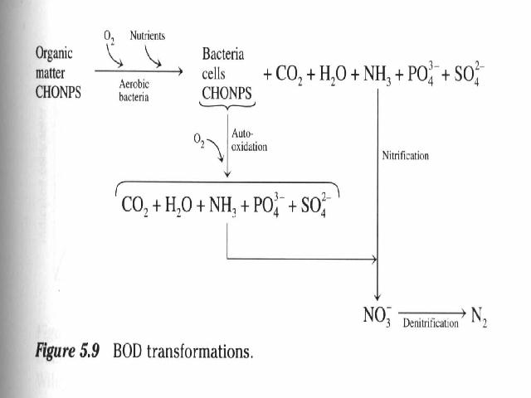
Recall: L = amount of organic matter expressed as O₂ remaining at any time, t (L_{t}).
$$\frac{\text{dL}}{\text{dt}}∝L \text{so} \frac{\text{dL}}{\text{dt}}=−k, L$$
$$X=L_{a}−L=L_{a}(1−{\text{10}}^{−k, t})=L_{a}(1−e^{−k, t})$$
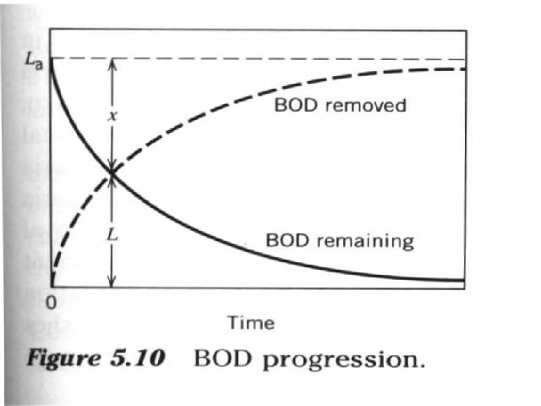

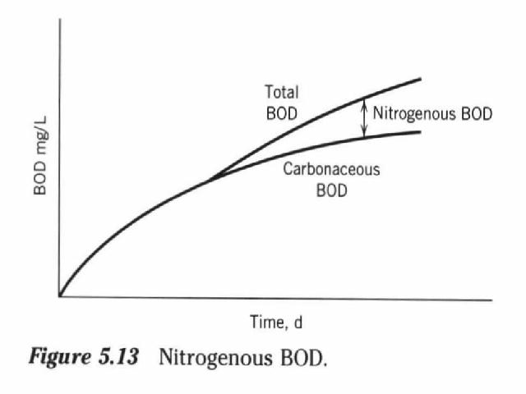
  - Streeter Phelps
    - TOC analysis, purge with acid:
$${\text{CO}}_{3}^{2−}, {\text{HCO}}_{3}^{−}, H_{2}{\text{CO}}_{3}→{\text{CO}}_{2(\text{aq})}→{\text{CO}}_{2(g)}$$
    - In BOD bottle- e.g. of a mixed culture batch system
