Lecture 9
CE260/Spring 2000

Physical Chemical Treatment
  - Particle removal process
    - Screens and bar racks
    - Type I, II, and III sedimentation
    - Grit chambers
  - Oxygen mass transfer
  - Coagulation & flocculation
  - Filtration
  - Water softening (remove hardness)
  - Ion exchange
  - Membrane process
  - Activated carbon
  - Disinfection

Screens and bar racks

Intakes from rivers, lakes, and reservoirs for water treatment plant
  - Sewer inlet to plants
  - Protect pumps in pumping station
    - Coarse 50 – 150 mm
    - Medium 20 – 50 mm
    - Fine <10mm
    - Don’t want something in front of these, will block flow (V_{min} = 0.6 m/s)

V_{Se}
h₂
Δh
h₁

  - Bernoulli’s equation used for headloss calculations
$$h_{1}+\frac{V^{2}}{2g}=h_{2}+\frac{V_{\text{Se}}^{2}}{2g}+\text{losses}$$
    - Can use friction factor, C_{d} to describe losses
$$\begin{aligned}Δh=h_{1}−h_{2}=\frac{1}{2{\text{gC}}_{d}^{2}}\left(V_{\text{Se}}^{2}−V^{2}\right) \\ \text{Typically} C_{d}=0\text{.}\text{84}\end{aligned}$$
    - Can use orifice equation for velocity through screen
$$Δh=\frac{V_{\text{Se}}^{2}}{2{\text{gC}}_{d}^{2}}=\frac{1}{2g}{\left(\frac{Q}{C_{d}A}\right)}^{2}$$
    - Mechanically cleaned screens, get C_{d} from manufacturer
    - Manually cleaned screen need A_{d} = 0.05 A_{actual}
    - Quantities of screens and disposal must be considered
      - Water treatment 1.3 mm openings – 0.29L/1000 m³ of Q
      - WWTP 50 to 150 mm screens at inlet with bar racks, 25 mm for other parts of the plant (see table 11.1 for estimates of WWTP)
      - 3.5 to 35 L/1000 m³
      - solids content 640-1100 kg/m³
      - ρ_{b} = 40 – 70 lb/ft³
      - %VS = 75 – 95%
      - Fuel value – 12,600 kJ/kg (5,400 Btu/lb)
  - Microstrainers – usually rotating drum with fabric (Fig. 11.4)
    - Design Parameters
      - Mesh size 20 – 25 um
      - Hydraulic loading 12 – 24 m³/m² hr
      - Max h_{L} 30 – 45 cm
      - Peripheral drum speed 4.5 m/min at 7.5 cm h_{L}
      - Wash water at 2 – 5%
      - Secondary effluent w/ TSS 6 – 65 mg/L, removal 43 – 85%
      - Can be used for stormwater and algae removal

Sedimentation
  - Type I
    - Assumptions
      - Discrete particle
      - Infinite size vessel
      - Viscous fluid
      - Single particle
      - Quiescent fluid
    - Bassett’s 1888 eq. for force balance for terminal velocity

Change in momentum = particle weight – buoyant force – drag force
$$\begin{aligned}m\vec{a}={\vec{F}}_{g}+{\vec{F}}_{b}+{\vec{F}}_{d} \\ −ρ_{p}V_{p}\frac{\text{dV}}{\text{dt}}=ρ_{p}V_{p}g−ρ_{w}V_{p}g+\frac{1}{2}C_{D}A_{p}V_{s}^{2}\end{aligned}$$
    - When particle reaches terminal V dV/dt = 0, rearrange
$$\begin{aligned}V_{s}=\sqrt{\frac{2g}{C_{D}}\frac{V_{p}}{A_{P}}\left(\frac{ρ_{p}−ρ_{w}}{ρ_{w}}\right)} \\ \text{for} \text{spherical} \text{particle} \\ V_{s}=\sqrt{\frac{4}{3}\frac{V_{p}}{A_{P}}\left(\frac{ρ_{p}−ρ_{w}}{ρ_{w}}\right)} \\ C_{D}=f\left(\text{Re}\right) \text{for} \text{Re}=\frac{ρ\text{Vd}}{μ}\end{aligned}$$
$$C_{D}=\begin{aligned}\left\{\frac{\text{24}}{\text{Re}} \text{for} \text{Re}<1 \text{la}\text{min}\text{ar} \text{flow} | \right\}\left\{\frac{\text{24}}{\text{Re}}+\frac{3}{{\text{Re}}^{12}}+0\text{.}\text{34} \text{trans}\text{.} \text{flow} 1<\text{Re}<{\text{10}}^{3} | \right\}\end{aligned}\left\{\right\}$$
    - Type I settling tank typical equations
$$\begin{aligned}t=\frac{V}{Q} V_{f}=\frac{Q}{\text{BH}} v_{o}t_{d}=H v_{f}t_{d}=L \\ \frac{L}{v_{f}}=\frac{H}{v_{o}} \text{and} v_{o}=v_{f}\frac{H}{L}=\frac{Q}{\text{BL}}=\frac{Q}{A_{s}}\end{aligned}$$
    - Sedimentation designs theoretically ≠ f(H)
    - If upflow sedimentation basin ↑V_{f} Q/A_{s}
↑V_{f}
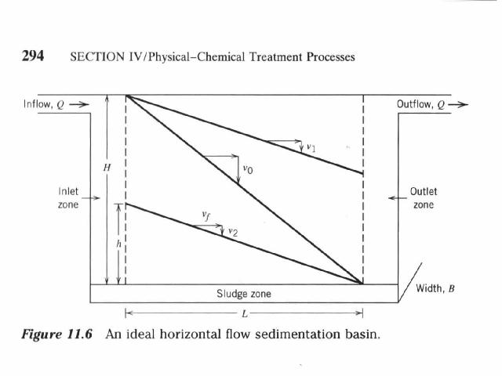
    - If v_{f} = v_{o} then all particles w/ v ≥ v_{o} will be removed
    - If v ≤ v_{o} then particle will pass by
    - If horizontal flow some particles with v < v_{o} will be removed, if they enter at h < H
    - Assume particle w/ v < v_{o} will travel a vertical distance h in one t_{d}
    - All particles with settling v are uniformly distributed in inlet zone
$$\begin{aligned}h={\text{vt}}_{d} \frac{h}{H}≤\frac{v}{v_{o}} \\ r=\frac{h}{H}=\frac{v}{v_{o}}\end{aligned}$$
    - Can be shown that the R = fraction by weight of all different sized particles removed is the sum of individual particle sizes removed
    - Figure 11.7 is a settling velocity curve for a suspension
$$\begin{aligned}R=1−p_{o}+\sum{r_{i}} \\ R=1−p_{o}+\frac{v_{o}+v_{1}}{2v_{o}}\left(p_{o}−p_{1}\right)+\frac{v_{1}+v_{2}}{2v_{0}}\left(p_{1}−p_{2}\right)+⋯ \\ \text{lim}\text{it} \text{is}: R=\left(1−p_{o}\right)+\frac{1}{v_{o}}\int_{0}^{p_{o}}{\text{vdp}}\end{aligned}$$
      - To solve for R use a polynomial fit or graphic interpolation (as in Fig. 11.7)
    - For circular tanks w/ inlet in middle and radial flow
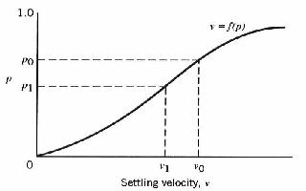
$$v_{o}=\frac{Q}{A_{s}} r=\frac{h}{H}=\frac{v}{v_{o}}$$

  - Type II sedimentation
    - Some agglomeration usually with natural or man made chemical agents
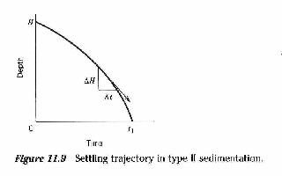
    - Flocculant type settling (Fig. 11.9 graph of settling trajectory)

    - Test for flocculation (jar tests) use columns to measure settling
    - Examples of data obtained during flocculation test w/ C_{o} = 430 mg/L
Raw Data | Concentration mg/L
Time (min) | 60 cm | 120 cm | 180 cm
5 | 357 | 387 | 396
10 | 310 | 346 | 366

Raw Data | Solids Removed %
Time (min) | 60 cm | 120 cm | 180 cm
5 | 17.0 | 10.0 | 7.9
10 | 28 | 19.5 | 14.5

    - Figure 11.12 is the percent solids removed at each depth, which can be easily used to interpolate the solids removed at any depth
Interpolated | t, min
% SS removed | 60 cm | 120 cm | 180 cm
5 | 1.2 | 2.5 | 3.7
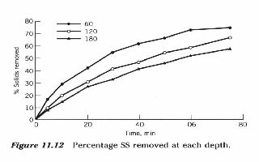  10 | 2.5 | 5.0 | 6.5
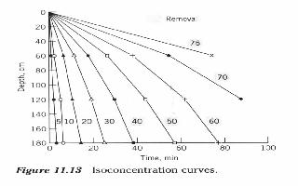
    - Figure 11.13 shows the isoconcentration curves
    - Fraction removed
$$r_{i}=\frac{d_{i}}{D}{Δp}_{i} \text{or} \frac{v_{i}}{v_{o}}=\frac{d_{i}}{D}$$
      - d_{i} = average depth reached by the i^{th} fraction
      - D = effective settling depth
      - v_{i} = average settling velocity of the i^{th} fraction
      - At time 45 min (book is wrong) from Figure 11.13 % removed is:
$$\begin{aligned}{Δp}_{i}=\text{50}−\text{40} \\ d_{\text{SS}\text{\%} \text{removed}}=\text{130}\text{cm} \\ D=\text{180}\text{cm}\end{aligned}$$
$$\begin{aligned}\frac{\text{130}}{\text{180}}\left(\text{50}−\text{40}\right)=7\text{.}2 \\ \frac{\text{78}}{\text{180}}\left(\text{60}−\text{50}\right)=4\text{.}3 \\ \frac{\text{48}}{\text{180}}\left(\text{70}−\text{60}\right)=2\text{.}7 \\ \frac{\text{70}}{\text{180}}\left(\text{75}−\text{70}\right)=0\text{.}8\end{aligned}$$
$$R=r_{o}+\sum{r_{i}=\text{40}+7\text{.}2+4\text{.}3+2\text{.}7+0\text{.}8=\text{55}\text{\%}}$$
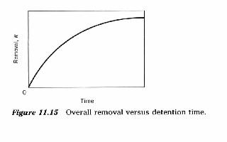
    - The next step is to create a figure of R vs t
      - Must consider increase of R at cost of obtaining t
      - Compare to other removal processes
      - Sizing of basin consider safety factors
        - Multiply design t_{d} based on column performance by 1.25 – 1.75
        - Divide design Q/A based on column performance by 1.25 – 1.75
      - Can use tube or lamella clarifiers
  - Type III sedimentation – zone settling, hindered settling
    - Generally w/ TSS > 500 mg/L in flocculation suspension (Figure 11.21 progression of zone sedimentation)
    - If t is to great will get anaerobic condition release CH₄ and CO₂
    - Can use 2 L graduated cylinder to gather data for zone sedimentation
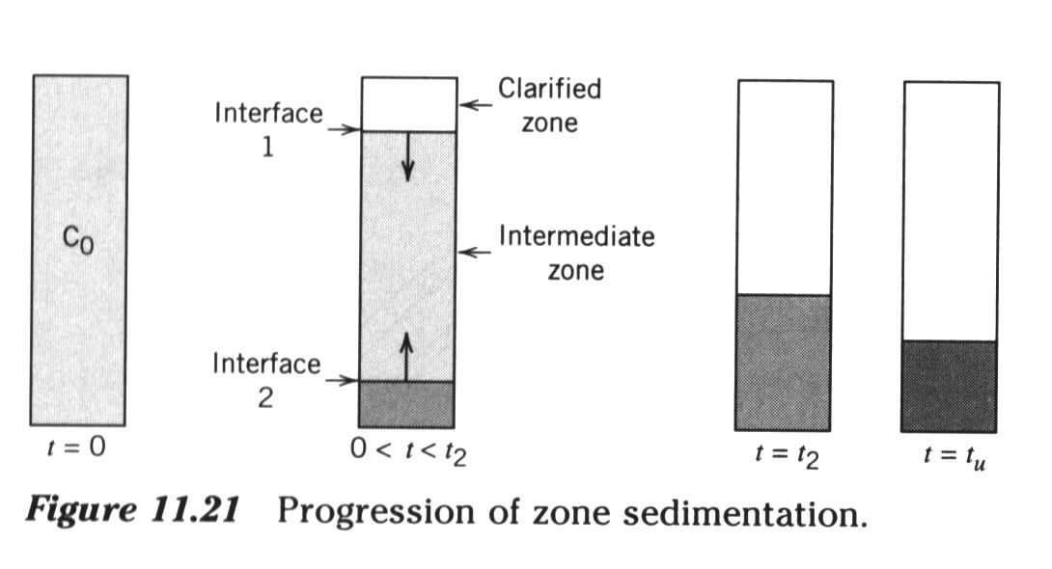
    - Generally design clarifiers to settle TSS out from clarified effluent and thicken sludge (Figure 11.23)
    - Interface settling rate for type III sedimentation
$$N=−\text{vC}$$
      - N = solids flux
      - v = interface volume in the tank occupied by sludge
      - C = concentration of the suspension
    - Design of Type III settlers
      - Figure 11.27 give the preliminary plots for gravity flux determination
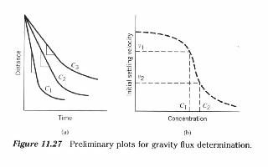
$$N_{g}=C_{i}v_{h}$$

      - C_{i} = initial concentration of the suspension
      - Look at Figure 11.28 which represent the mass flux from gravity
      - Vesiland equation used to describe settling velocity of a suspension at any concentration
$$v_{h}={\text{ae}}^{−\text{bC}}$$
      - Years later Wahlberg and Keinath defined a and b as follows:
$$v_{h}=\left[5\text{.}3−0\text{.}\text{061}\left(\text{SVI}\right)\right]e^{\left[−0\text{.}\text{426}+\left(0\text{.}\text{00384}\right)\left(\text{SVI}\right)−\left(0\text{.}\text{0000543}\right){\left(\text{SVI}\right)}^{2}\right]C}$$
      - Underflow flux in addition to gravity solid flux
        - Underflow increases downward movement of solids
$$\begin{aligned}U_{b}=\frac{Q_{u}}{A_{s}}=\text{underflow} \text{velocity} \\ N_{u}={\text{CU}}_{b}=\text{underflow} \text{solids} \text{flux}\end{aligned}$$
      - Total solids flux = N
$$N=N_{g}+N_{u}={\text{Cv}}_{h}+{\text{CU}}_{b}$$
      - Figure 11.29 Total mass flux as a f(conc)
$$A_{s}≥\frac{{\text{QC}}_{o}}{N}=\frac{\text{solids} \text{loading}}{\text{total} \text{solids} \text{flux}}$$
      - All solids are removed by bulk flow (underflow)
$$C_{u}Q_{u}={\text{QC}}_{o}=A_{s}N_{L}$$
  - Other important issues for sedimentation
    - Weir – design and geometry – important to have minimum velocity of water over the weir
    - Launder design channel for transient flow don’t want to flood launder
  - Basic properties
    - Water treatment
      - Depth 2.4 – 4.9 m, SOR 20 – 70 m²/m³-day
    - WWTP
      - Primary – depth 2.1 – 5 m, avg. Q 32 – 49 m³/m²-day, peak 49 – 122 m³/m²-day
      - Secondary - depth 3.0 – 5.0 m, avg. Q 16 – 29 m³/m²-day, peak 41 – 65 m³/m²-day

