Lecture 10
CE 260 Spring/2000

Coagulation and Flocculation
  - Coagulation is the destabilization of colloidal particles
    - Colloids – macromolecules and small particles that do not readily settlte out of suspension (e.g. clays, hydrous metal oxides, bacteria, viruses, proteins, pulp fibers = 1 um in size)
  - Stability of colloidal suspension
    - Varies greatly
    - Thermodynamically stable – are called reversible, can make unstable for short time but will become stable suspension again
    - Thermodynamically unstable – irreversible, (e.g. MOH_{x}, viruses, and bacteria) we can aggregate these particles
  - Stability of particles is related to surface charge, the charge is a f(functional groups)
    - Acidic, basic, aphoteric OH groups on colloidal oxides –OH, silicates …
    - Localized –OH sites and O sharing in SiO₄, AlO₆, and AlO₄ – clay zeolites
    - Ionizable surface sites on slightly soluble compounds
    - Acidic and basic functional groups on organic colloids, polysaccharides
  - Surface charge is related to ionization or protolysis of functional groups.
    - Therefore pH and ion content of aqueous phase
    - pH at which a colloid with an acidic functional group changes from uncharged to – charge is related to the pKa of those groups
    - e.g. carboxylic acid functional group on a protein has a pKa ~ 4 to 5, therefore a pH 4 colloid is uncharged and relatively unstable: @ pH 5 charges increase and stable suspension results (this is true for many microbial systems)
    - pH value at which the net surface charge is 0 is the zero point of charge (ZPC) therefore the zeta potential is zero (Er)
    - zeta potential is the net charge potential at a particular distance from the particle surface
  - Since colloidal dispersions are not charged so the primary charge on particle must be counterbalanced by the solution
  - Therefore an electrical double layer exist at the interface between the colloid and solution
    - The double layer has the charged particle and counterions of opposite charge equivalent to excess charge on the particle
    - Zeta potential expressed in following figures
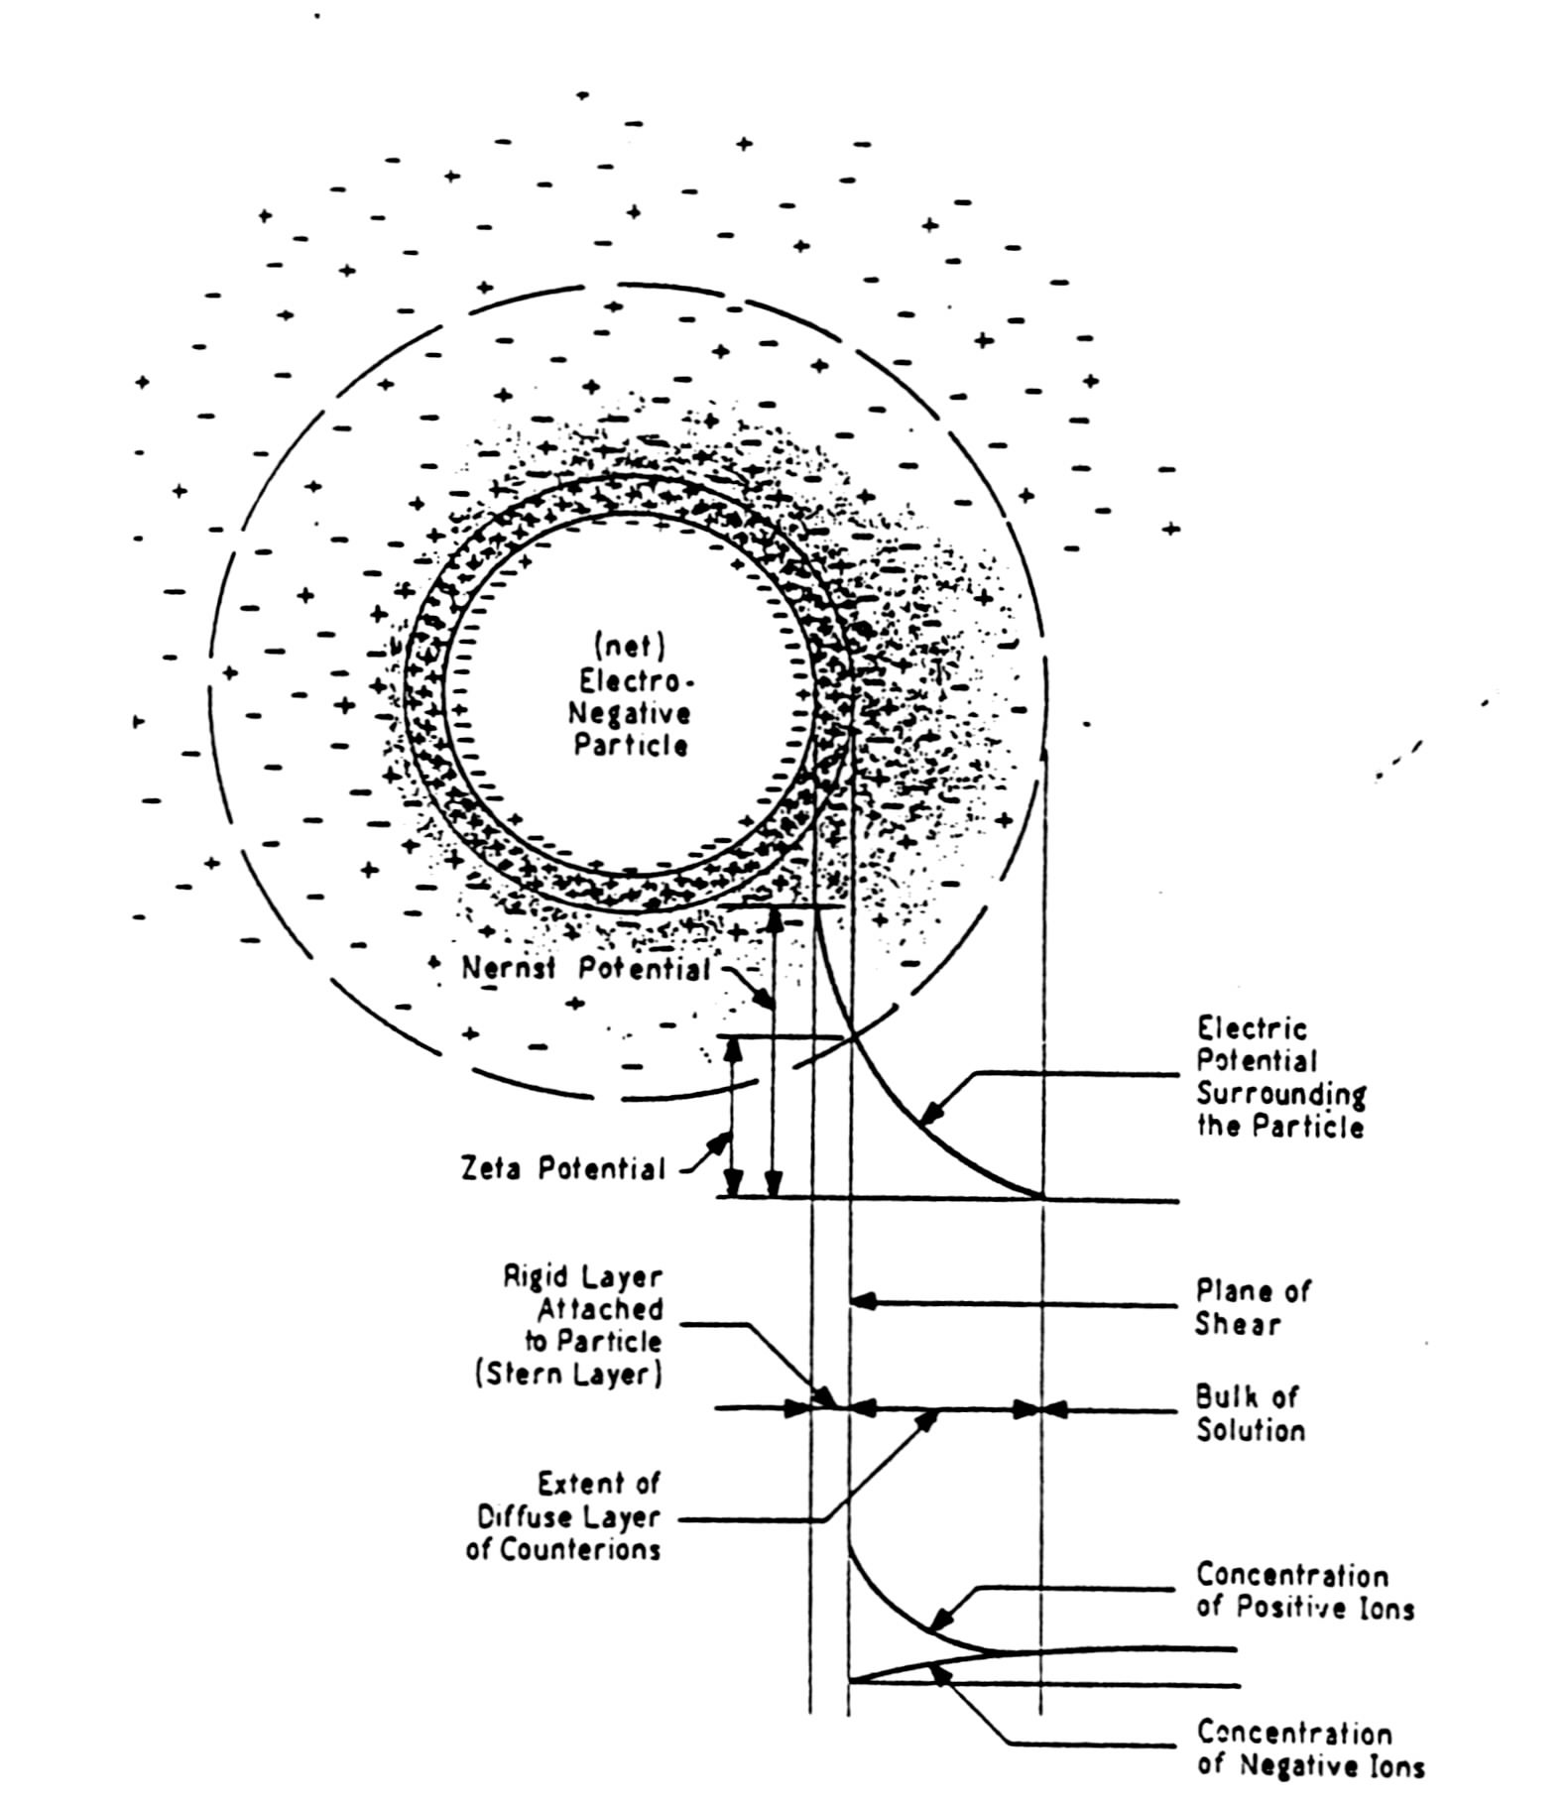

Composition | pH_{ZPC}
αSiO₂ (quartz) | 2.9
δ-MnO₂ (birnessite) | 2.2
α-Al(OH)₃ | 5.0
γ-Al₂O₃ | 8.5
CaCO₃ (calcite) | 9.5
CuO | 9.5
    - Basically what this means is that salt in solution can mobilize ions
  - Common coagulants
    - Al₂(SO₄)₃ alum sulfate (optimum pH 5.5-6.3)
    - Fe₂(SO₄)₃ ferric sulfate (opt. pH 4.5-5.5)
    - Benefits
      - Adds cation 3+ valance state of metal
      - Hydroxides are very insoluble
    - Relative power of coagulants:
 | + colloids | - colloids
Al₂(SO₄)₃ | 30 | >1000
Fe₂(SO₄)₃ | 30 | >1000
NaCl | 1 | 1
Na₃PO₄ | 1000 | 1
  - Chemistry of aluminum, iron salts and lime
    - Alum (pH decreases)
Al₂(SO₄)₃⋅18H₂O + 6H₂O → 2Al(OH)_{3(s)} + 6H⁺ + 3SO₄²⁻ + 18H₂O
      - If alkalinity is present then
HCO₃⁻ +H⁺ ↔ H₂CO₃ ↔ CO₂ +H₂O
      - So pH will remain neutral, If lime is needed
Al₂(SO₄)₃⋅18H₂O + 3Ca(OH)₂ → 2Al(OH)_{3(s)} + CaSO₄ + 6CO₂ + 18H₂O
    - Ferrous sulfate
Fe₂SO₄⋅7H₂O + Ca(OH)₂ → Fe(OH)₂ + CaSO₄ +7H₂O
4Fe(OH)₂ + O₂ +2H₂O → 4Fe(OH)_{3(s)}
Mixing and power dissipation – Newton’s law of viscosity for 1-D
$$τ_{\text{yx}}=−μ\frac{{\text{dv}}_{x}}{\text{dy}}$$
  - Where:
    - τ_{yx} = shear force per unit area in the x direction
    - dv_{x} = velocity in the x direction
    - y = vertical direction
    - μ = dynamic viscosity
$$\begin{aligned}\text{If} P=\vec{F}⋅\vec{V} \text{then}, \\ τ\frac{\text{dv}}{\text{dy}}=\frac{ΔP}{ΔV}\end{aligned}$$
    - ΔP = power change
    - ΔV = volume change
    - Applying Newton’s law of viscosity
$$μ\frac{\text{dv}}{\text{dy}}=\frac{ΔP}{ΔV}$$
    - In a fixed volume vessel, well mixed
$$\frac{ΔP}{ΔV}=\frac{P}{V}$$
    - Defining G as the velocity gradient (dv/dy)
$$\begin{aligned}{μG}^{2}=\frac{P}{V} \text{or} G={\left(\frac{P}{μV}\right)}^{1/2} \\ P=ρ{\text{gQh}}_{L}\end{aligned}$$
    - Q = volumetric flowrate
    - h_{L} = head loss
    - Once P is calculated insert into G
    - G-t_{d} has been found to be correlated with mixers and flocculators
    - In 1973 Letterman developed an equation for the optimum Gt_{opt} (optimum detention time) for values of G up to 5000s⁻¹ used for water
t_{d}, s | 20 | 30 | 40 | >40
G, s⁻¹ | 1000 | 900 | 790 | 700
  - Mechanical and Pneumatic mixers
    - Impeller mixers are most efficient
      - Factors – geometry and basin impeller fluid characteristics, and $ power
      - Relationships
$$v∝\text{ND} A∝D^{2} P∝F_{D}v=F_{D}\text{ND}$$
        - v = velocity of impeller
        - N = rpm (s)
        - D = impeller diameter
        - F_{D} = drag force
        - P = power expenditure
    - Types of impellers Figure 13.5
$$\begin{aligned}C_{D}=\frac{2F_{D}}{ρ{\text{Av}}^{2}}=\frac{2F_{D}v}{ρ{\text{Av}}^{3}} \\ φ=\frac{P}{{ρN}^{3}D^{5}} \\ \text{Re}=\frac{ρ{\text{ND}}^{2}}{μ}\end{aligned}$$
      - φ = power #, manufacturers list characteristics
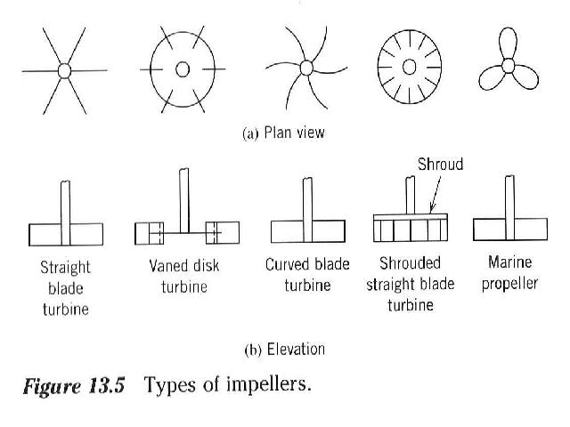

Flocculators
D
v_{p} = paddle
v_{f} = fluid
1/2D
r_{L}
b

  - b= length of paddle
  - Relative velocity
$$\begin{aligned}v=v_{p}−v_{f}=v_{p}−{\text{kv}}_{p}=v_{p}\left(1−k\right) \\ v_{p}=\frac{2πN\bar{r}}{\text{60}} \\ F_{D}=\frac{1}{2}{ρC}_{D}{\text{Av}}^{2}\end{aligned}$$

$$\begin{aligned}\text{not} \text{dA}=\text{bdr} \\ \text{dP}={\text{dF}}_{D}v=\frac{1}{2}{ρC}_{D}v^{3}\text{dA} \\ P=\frac{1}{2}{ρC}_{D}b{\left[\frac{2πN}{\text{60}}\left(1−k\right)\right]}^{3}\int_{r_{i}}^{r_{o}}{r^{3}}\text{dr} \\ P=1\text{.}\text{44}x{\text{10}}^{−4}C_{D}ρb{\left[N\left(1−k\right)\right]}^{3}r_{o}^{4}−r_{i}^{4}\end{aligned}$$
  - Recommended design parameters for paddle flocculators
    - Tip speed 0.09 – 0.9 m/s
    - k = 0.25 w/o stators, 0-0.15 w/ stators
    - C_{D} = 1.8 for flat blades
    - A_{B} = 15 to 20% of tank cross-sectional area
    - Max depth approx. 5m
  - Go over example 13.2
$h_{L}=f\frac{{\text{Lv}}^{2}}{D2g}$

