Sonoma Valley Treatment Plant Detailed Virtual Tour
Disinfection and effluent disposal:
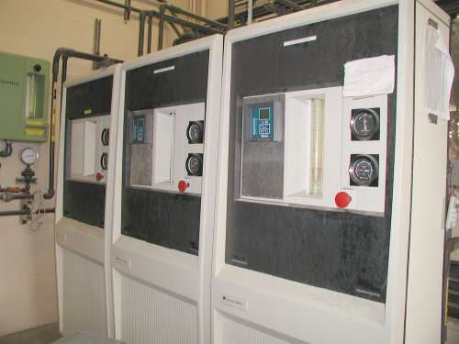
Gaseous chlorine and sulfur dioxide are used for effluent disinfection and dechlorination.

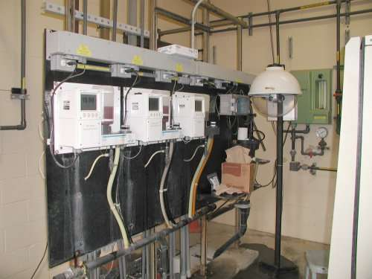
Chlorine residual analyzers continuously monitor the residual chlorine entering the contact chambers, leaving the contact chambers, and leaving the plant following dechlorination. This data is available and trended on the plant SCADA system.



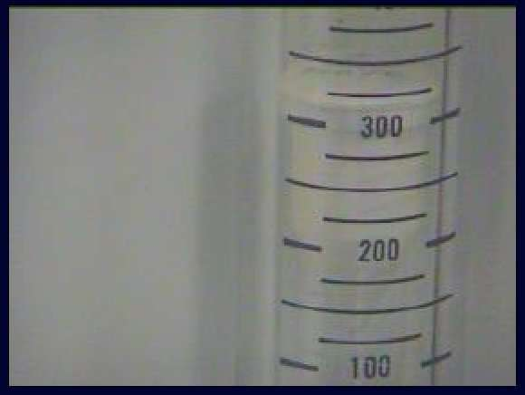

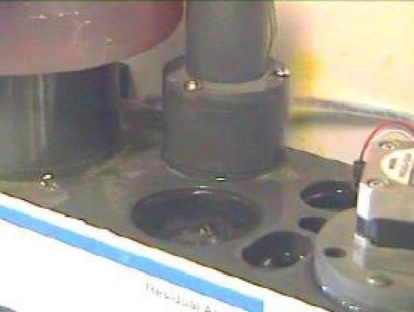
These three pictures are screen shots from an intranet accessed and controlled video camera which enables the remote monitoring of actual controller status, rotometer gas flow, and analyzer sample flow. This enhances the SCADA monitoring during any unmanned plant hours.

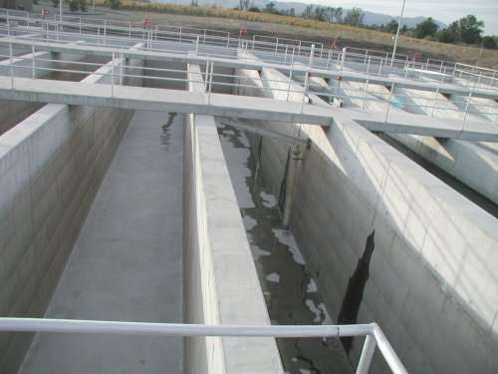

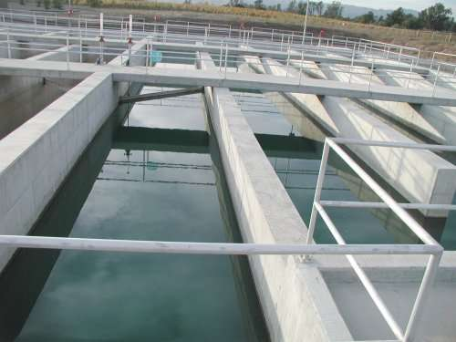
Two 0.4-MG serpentine contact tanks provide the time that the chlorine needs for good disinfection.

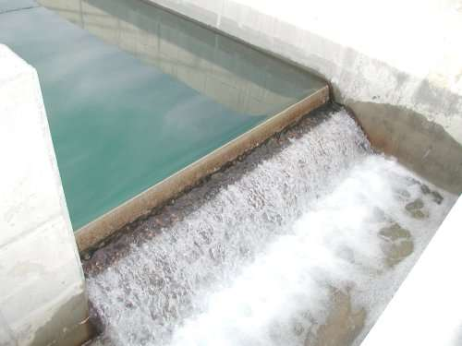

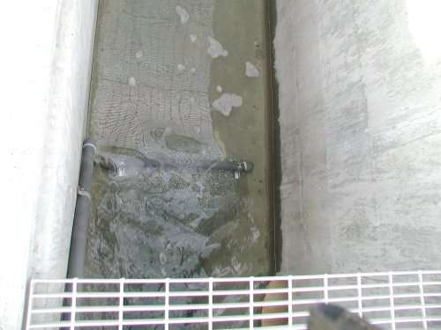
The contact chamber effluent overflows a weir and travels down a channel where a diffuser injects sulfur dioxide solution to neutralize any remaining chlorine residual during discharge season.

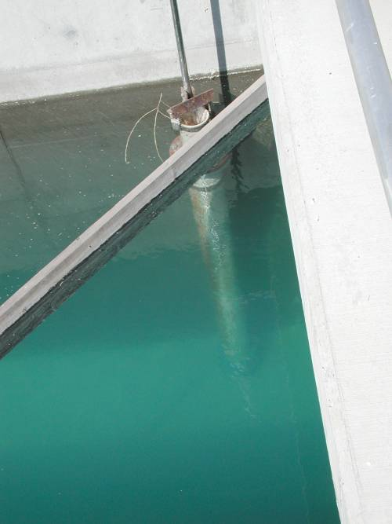
SVTP routinely produces final effluent with turbidities around two NTU. In this September 2001 photo, the entire telescopic scum pipe can be seen down to the floor of the contact chamber, thirteen feet deep.

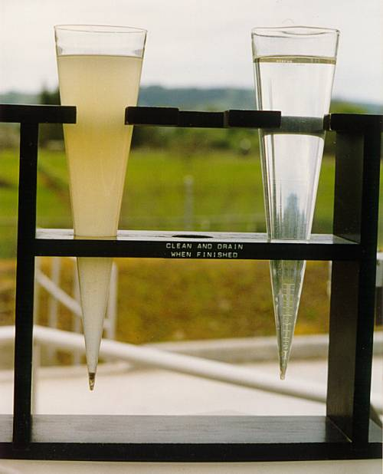
This comparison of SVTP influent and effluent is another good example of normal plant performance.

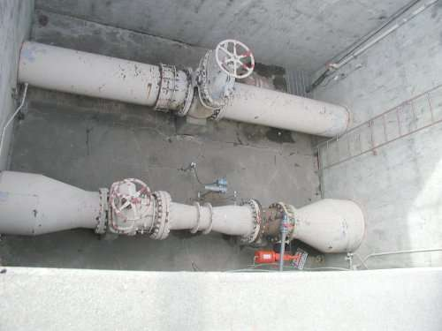
Final effluent flows first through an effluent wetwell where it can be either pumped or gravity discharged through this effluent valve and meter. The effluent valve has a pneumatic operator to immediately shut the valve based upon either a power failure or detection of any effluent chlorine residual during discharge season. The effluent wetwell then overflows to local storage until an Operator either resumes discharge or directs the effluent pump flow to the equalization basins.

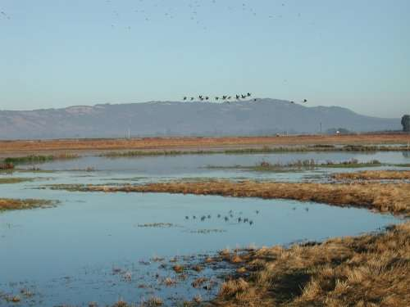
Final effluent is used to enhance wetland areas in the fall (above).
From May 1 to October 31 final effluent is used for dairy crop and vineyard irrigation.
From November 1 to April 31 final effluent is discharged to Schell Slough (a tidal tributary of San Pablo Bay).

