Sonoma Valley Treatment Plant Detailed Virtual Tour
Solids processing:
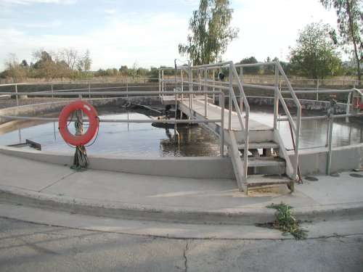
Waste activated sludge (WAS) is pumped through a drum screen which removes particulate trash, such as cigarete butts and pieces of plastic wrappers, and then flows to this gravity thickener. While the thickener provides some actual thickening, it primarily provides storage between continuous wasting of WAS and batch dewatering of that sludge.

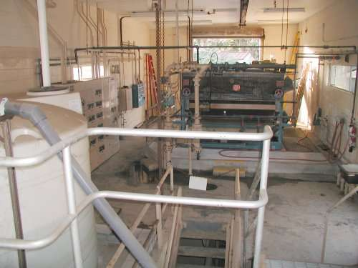
Polymer is injected into the sludge flow from the thickener as it travels to a belt filter press. The polymer coagulates the sludge particles together and the sludge is pressed between two pourous belts, which shed the water, while traveling through a series of pressure rollers.

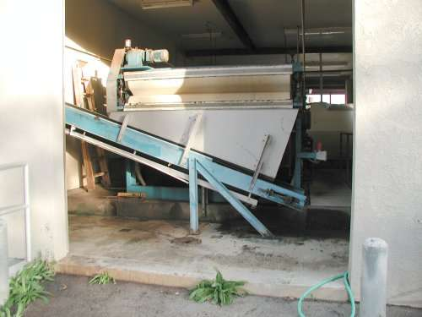
The dewatered biosolids cake is scrapped from the belts, onto a conveyor, that discharges into a bin, for disposal at a sanitary land fill.

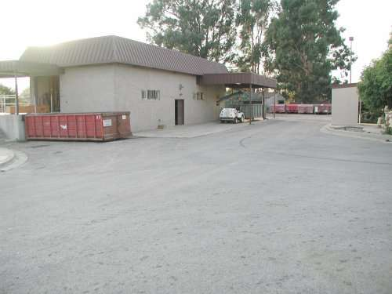
The District is investigating options for beneficial reuse of SVTP's dewatered biosolids.

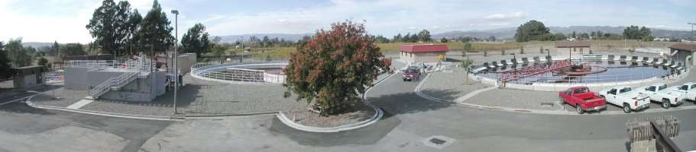
We hope you have enjoyed our virtual tour and might visit us in person one day soon.

