Sonoma Valley Treatment Plant Detailed Virtual Tour
Preliminary treatment:
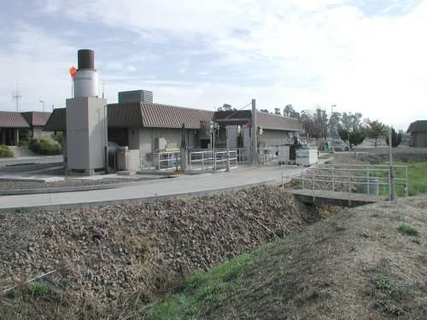
The plant headworks is on the south side of the influent-effluent pump bldg.

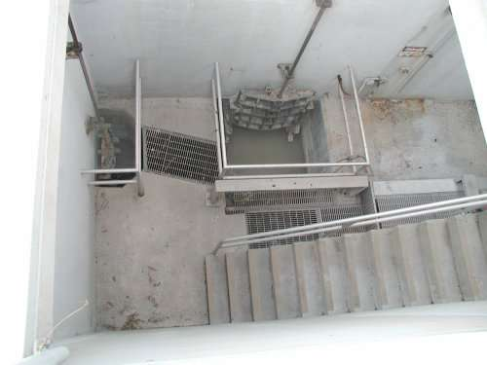
Raw sewage from the collection system enters through the headgate.

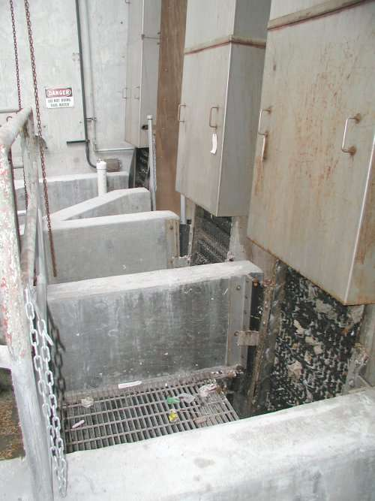
Three 3/4"-opening continuous filter screens are available for screening debris from the raw sewage.

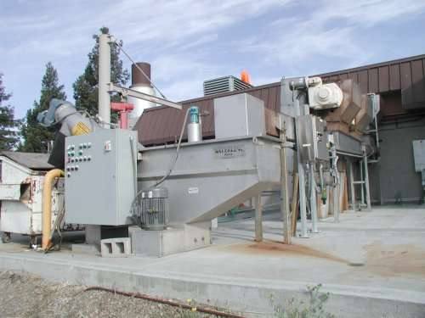
The screenings are conveyed to a washing system, which discharges to a bin for disposal at a sanitary landfill.

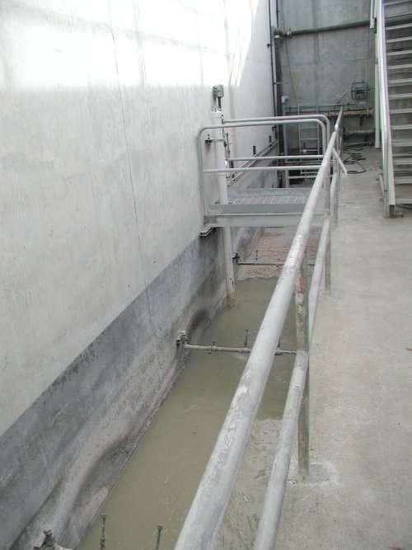
The flow then enters the influent wetwell.

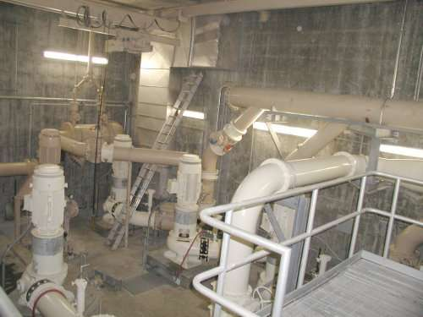
Five 10-MGD capacity influent pumps are available to lift the raw sewage from the influent wetwell to the grit chamber.

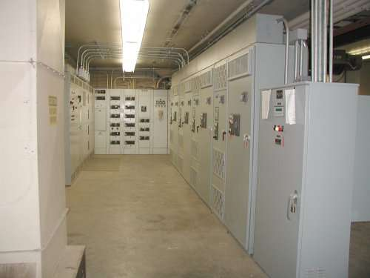
Four of the influent pumps are VFD controlled through a PLC, one is a full-speed only pump.

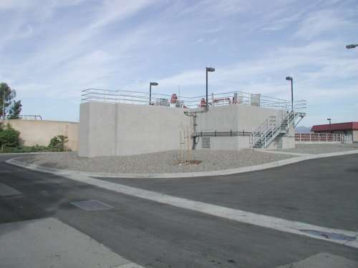
A Pista brand grit system is used to remove the heavy inorganic grit.

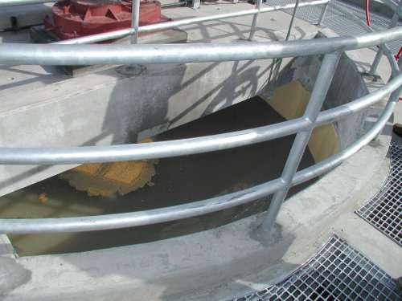
The circular chamber with rotating paddles keeps inorganics in suspension while drawing the grit to a smaller center well from where the slurry is pumped.

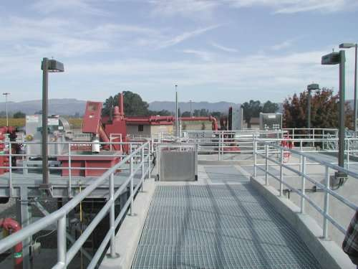
The slurry is pumped through a cyclone concentrator that discharges to a dewatering screw, which deposits the grit into a hopper.

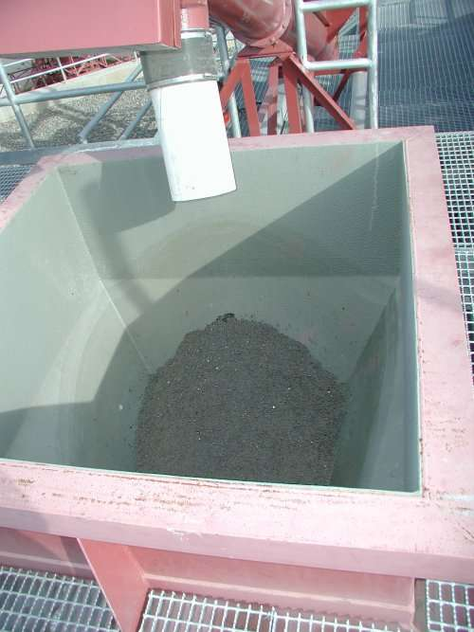
The system produces well dewatered grit, substantially free of putrescible organics.

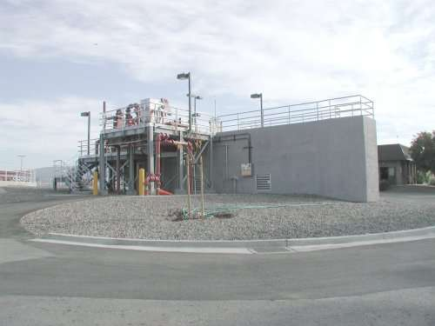
The grit hopper is emptied into bins for disposal at a sanitary landfill.

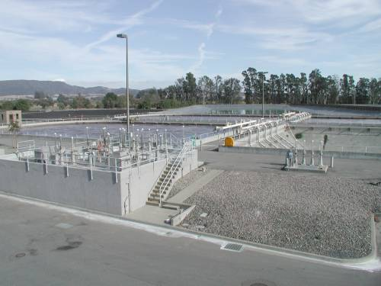
The grit chamber effluent (preliminary treated raw sewage) flows to the flow control structure where it can be introduced into secondary treatment or diverted to storm flow equalization basins.

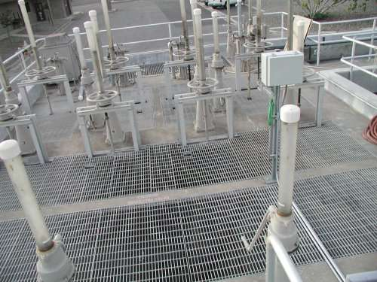
Storm flows in excess of the current plant treatment capacity of 12 MGD are bypassed at the flow control structure to four equalization basins with a total capacity of 35 MG.

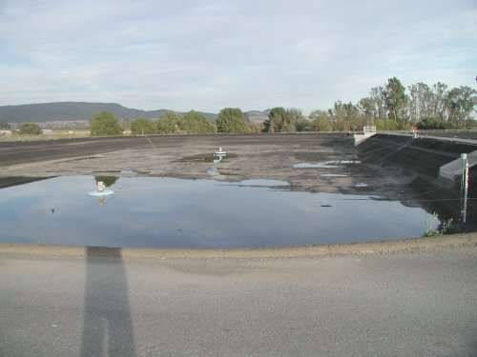

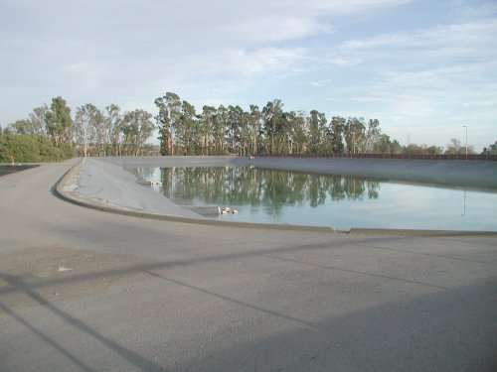
The equalization basins are filled in series starting with two small (2.5 MG each) aerated basins followed by two large (15 MG each) basins. Once storm flows subside below the plant treatment capacity of 12 MGD, the stored water is returned, to empty the available storage for future storm events.

